
South East England General Histopathology EQA Scheme Standard Operating Procedures
E EQALite Participant Manual
RWF-CP-EQA-SOP5

Revision No | 1.1
Date of Issue | April 2025
Replaces | Individual instructions
Author | Scheme Administrator
Document Lead | Scheme Manager
Lead approver (Document owner) | Scheme Manager
Review Period | 1 year
Paper Copy Number | n/a
For paper copies only: Authorised copy Signature (Lead approver or Document Lead)
Master Electronic Copy | QPulse
Location of authorised paper copies | None

Significant changes since last revision

Section | Change
2.3 | - Revised instructions for submitting responses if there is more than one diagnosis
Histology EQA Website:
https://www.histopathologyeqa.org
1 Personalising EQALite 3
1.1 Logging into EQALite 3
1.2 Registering exemptions 3
1.3 Changing workplace address 4
1.4 Participants leaving 4
2 Using EQALite 4
2.1 Submitting cases 4
2.2 Circulation lists for Glass Slides 5
2.3 Entering Responses 5
2.4 Scoring 9
2.5 Personal results and Reports 9
2.6 CPD report 10
2.7 Suspending participation 10
3 Seeking Help with EQALite 11

Personalising EQALite

Logging into EQALite
You will be sent an email advising your registration has been successful.
- Log into EQALite via www.histopathologyeqa.org
2. Enter your email address as your username (this email address needs to be the address that you registered with the scheme)
3. Click "Reminder" if you have forgotten or never had your password.
4. An email will be sent to you with your password.
5. Enter this password
6. You can change this password, update your address etc via the tab labelled "your details".
You may join the circulation after it has started, but be aware that if the glass slides have already been through your department, you will have to participate using the digital images only.

Registering exemptions
You may exempt yourself from a maximum of 4 diagnostic categories, if this reflects your clinical practice.
Please note:
  - The miscellaneous category is compulsory and is not available to select as an option.
  - Exemptions cannot be registered or changed once a circulation has started. Any amendments will take effect from the following circulation.
  - Exemptions may affect your ranking if you have a poor result in one or more of the cases in which you participate. Those with no exemptions and one poor result ((e.g. 9 out of 10 perfect scores) will score at least 90%. Those with 4 exemptions and one poor result (e.g. 5 out of 6 perfect scores) will only score at least 83%. Be aware that this may adversely affect your ranking.
To register exemptions or to find out which diagnostic categories you have already exempted from
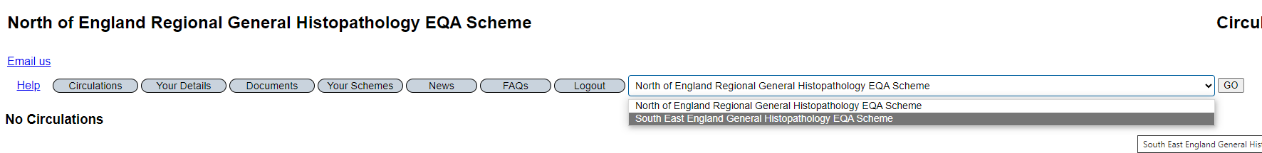

1

2
- Click “YOUR SCHEMES”
- Click on the dropdown arrow and select “South East England General EQA Scheme”
- Click on button “exemptions”
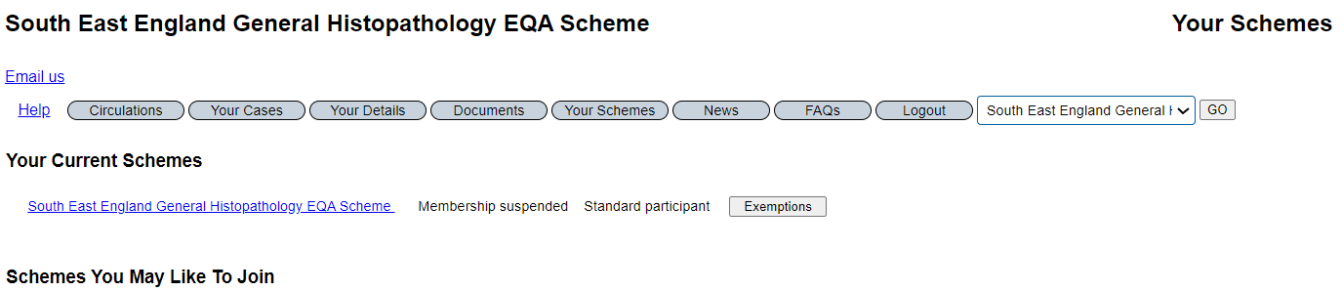
3
- Select the appropriate exemptions by clicking on the box and press save.
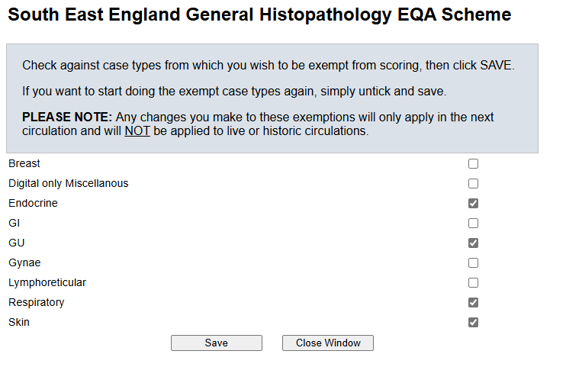
4
Do not select more then 4 exemptions. If you do, you will be prevented from taking part in the next circulation.

Changing workplace address
To amend workplace details click on “your details” and amend as appropriate.
If you relocate to a non-UK country and wish to remain within the Scheme, your status will be changed to “Overseas”. You will not receive glass slides and you will not be performance-monitored. This is because RCPath has no jurisdiction outside the UK. You will be scored and your personal report will show how you compare with the other participants.

Participants leaving
If you wish to leave the scheme, notify the scheme by email as described in the participant manual.

Using EQALite

Submitting cases
Cases can be submitted either using the manual case submission form available on the Scheme website (see Participant manual) or via an EQALite electronic submission form. Ensure diagnostic features are present on all slides before completing the form.
- Click on “Your Cases”. Make sure, if you belong to more than one scheme, that the South East England General Histopathology EQA Scheme is selected.
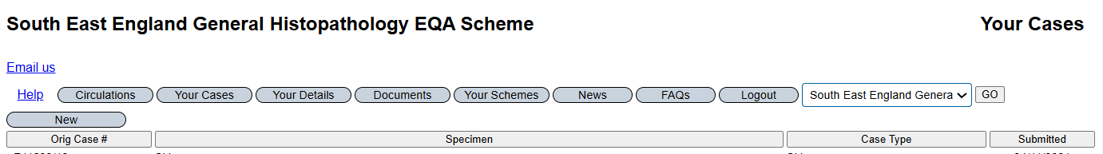
- Click on “New”. Fill in all the details. The original case number is the original laboratory number. Diagnosis & Notes – enter the reported diagnosis. You must confirm you have approval to provide the case material from your employing laboratory and you must have personally reported the submitted case or agree with the reported diagnosis.
- Press “Save”. You can return and change the details as often as you want, remembering to” Save” them each time.
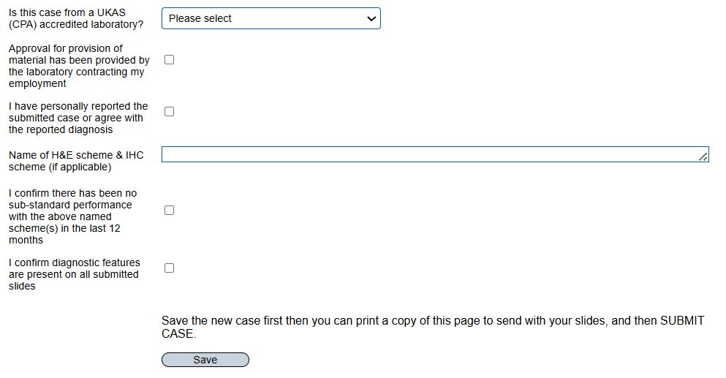
- When complete, print this to send with the slides. See Participant manual for how to package the slides.
- Then SUBMIT the case so that the Scheme administration has the details. From this point you will no longer be able to see the case details.

Circulation lists for Glass Slides
Circulation lists for the distribution of glass slides will continue to be issued in the same way as described in the participant manual

Entering Responses
All responses are submitted via EQALite. The response form includes all relevant information including the clinical details, type of specimen, macroscopic description and results of immunocytochemistry (if provided). There is a link to the digital image of the slide. There is provision for diagnostic opinions and weighted scoring and for recording the methodology used for making the diagnosis (glass slide, digital image or both). This is so that the scheme can periodically audit any bias between the two methods.
You should treat the material and information provided in the same manner as any routine histopathological sample. The slides consist of biological materials that have been fixed in formalin. Please provide a diagnosis, or a list of differential diagnoses, using current nomenclature, together with an assessment of their certainty of each, by provision of scores that add up to 10. Please click here to understand the scoring protocol for cases

- Log in (see section 1.1)
- EQALite allows participants to be a member of more than one EQA Scheme. To swap between schemes, use the scheme dropdown at the top-right of most pages. Selecting another scheme should change the scheme, but very rarely you may need to click GO
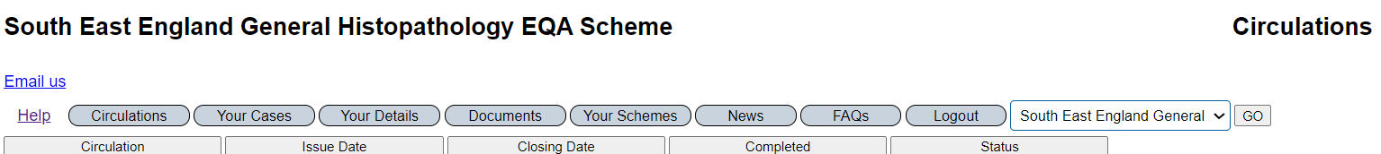
- The list of circulations will appear.
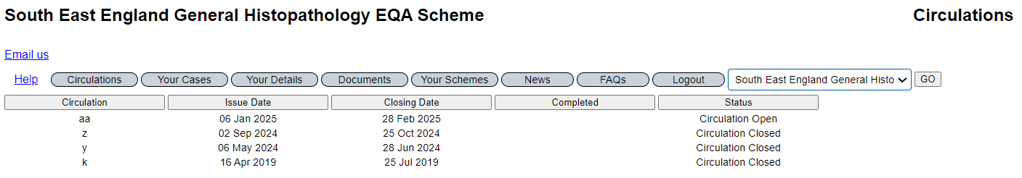
- Click on the open circulation
- The Cell number is your slide group. The circulation number is the order in which your department receives the slides within the slide group.
- The list of cases appears across the screen
- If you cannot 'see' a live circulation then it is possible that you were not included when the circulation was issued, perhaps because you registered after the circulation was issued, or you had suspended your membership at the time. Contact the EQA Scheme administrator.
- You can print out case histories by clicking on "Circulation Preview". This will open a Word document that you can save or print out.
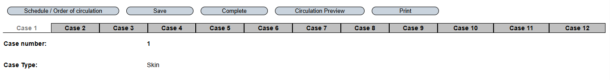

- Click on Case1
- The link to the slides is under the immunocytochemistry (if any)
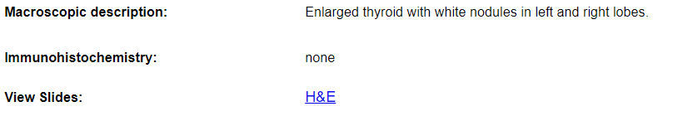
- The quality of the digital image is dependant on the band width, speed of internet connection and resolution of the screen. See guidelines for using digital images https://www.mtw.nhs.uk/wp-content/uploads/2024/10/Guidelines-for-using-digital-images-for-EQA_Li23v1.0.pdf
- Enter a single free text diagnosis and a weighting (confidence level) for this diagnosis. If you are 100% confident of this diagnosis, enter a weighting of 10 and click ADD
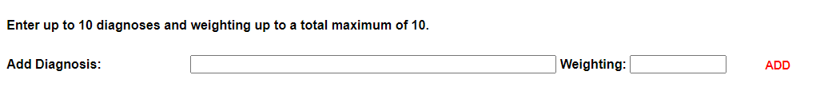
- If you are undecided between two or more diagnoses, put each diagnosis on a separate line and allocate weightings that add up to 10.
- If you believe there actually are two or more diagnoses in the same case, put all diagnoses on the same line with appropriate weighting.
- To add a second (or third) diagnosis, enter another diagnosis and apply weightings (confidence level) to each diagnosis. Click ADD after adding each diagnosis and weighting. The sum of all weightings must total 10. Do not put two diagnoses in the same box unless you believe there is more than one diagnosis in the case. This will adversely affect your score. The diagnoses cannot be split out within EQALite by scheme administration.
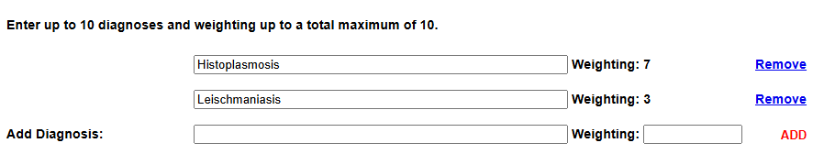
- To remove a diagnosis, click “Remove”
- Do not add punctuation to the end of the diagnosis
- Use the dropdown box to select the methodology used to make the diagnosis (glass slide, digital image or both).
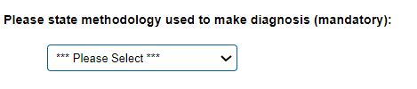
- When satisfied with your answer, Click on the SAVE button (not the COMPLETE button) and click on next case tab.
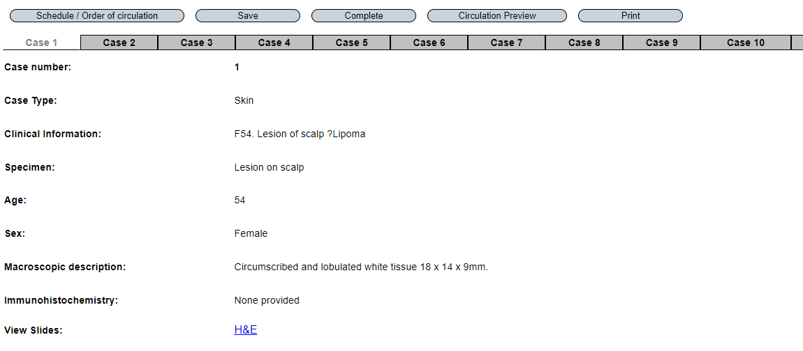
- If you have registered exemptions prior to the start of the circulation, this will show when you click on the case tab. Do not answer this question, it will not be scored. Click on the next case tab to continue answering questions for the circulation.
Note: you exempt from an organ system, not a diagnosis. If “exempt” is not shown, you must answer the case, otherwise you will be scored zero for that case. You can change your exemptions but any changes to exemptions will only apply to the next circulation, not the current circulation.

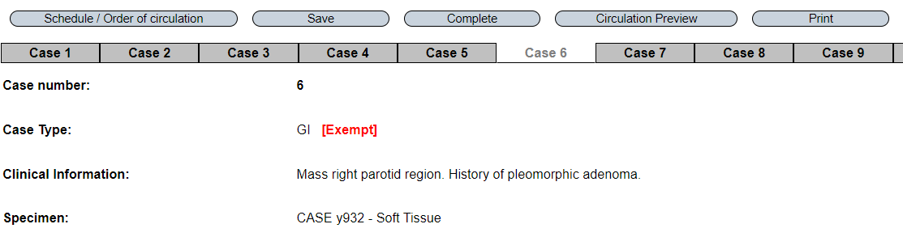
- If you want to stop before you are ready to submit final answers then click SAVE. You can print out your answers at any stage using the “Print” button. Save to pdf.
- When you have completed all your answers, click “COMPLETE” to submit the answers. Once submitted your answers cannot be changed. You will not be able to submit the answers if you have missed a tab and you are not exempt from that diagnostic category, or if the weightings for a case do not add up to 10. Go back to the relevant case(s) and correct the entry. Save and then click “Complete”
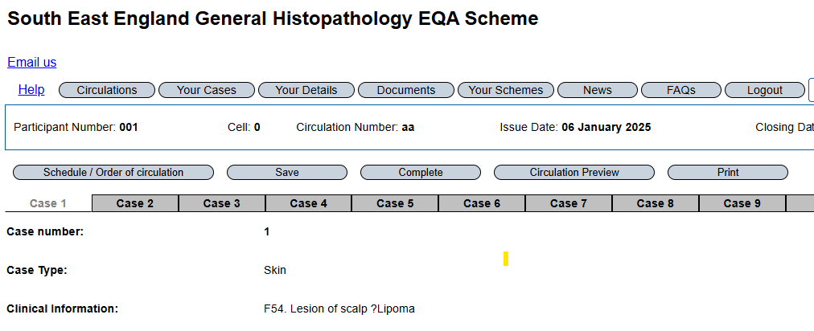
- Participants are required to confirm response authenticity, to affirm your responses are solely yours and not influenced by discussions with colleagues.
- Save a copy of your submitted diagnoses. Click Print and save to pdf in a folder of your own choosing.
- Click on the Circulations tab. A date will appear in the Completed column confirming that you have completed that circulation.
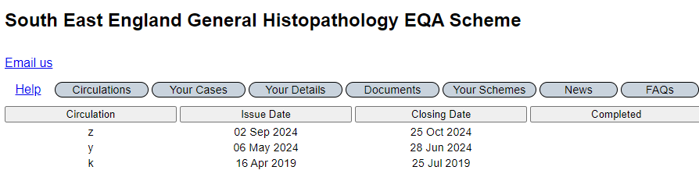
- If there is no date in this column, click on the open circulation (e.g. z) and press “Complete”.

Scoring
Submitted diagnoses are merged in accordance with the consultation process (see participant manual). EQALite then calculates the score for each diagnosis (based on sum of weightings for that diagnosis from all participants) and then personal scores. There is no “marking” by the Organiser. See Scoring protocol https://www.mtw.nhs.uk/wp-content/uploads/2023/05/scoring-protocol-presentation-v1.3-2023.pptx for details on how scores are achieved. This scoring system has been approved by the RCPath Interpretive EQA Steering Committee.

Personal results and Reports
After final merges, personal results are available to download from EQALite.
- Click on “Circulations” tab.
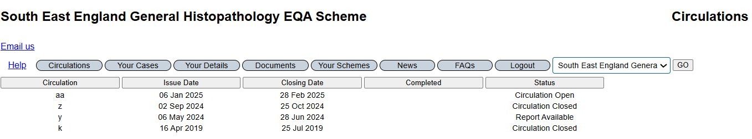
- Open circulation with status “Report Available”.
- Press “Report”
Interpretation:
- “Your Score” – score per case
- “No. responses” – number of participants answering that case
- “Your main diagnosis” – the diagnosis (or diagnoses) you submitted, with weightings. Please note, if your diagnosis has been merged with another, the merged diagnosis will be shown.
- “Average Score” – the % consensus for the preferred main diagnosis e.g. Average score 0.89 = 89% consensus
- Preferred main diagnosis – the “correct” answer as determined by consensus
- “Lowest Score” – the % consensus of the lowest-scoring submitted diagnosis
The report includes your ranking and a histogram giving the distribution of the accumulated “scores” of the recent circulations you have participated in. If your ranking is close to the bottom (e.g. 158 of 162), you may be in the bottom 3%.
Those in the bottom 3% will be sent a copy of their results in the post, highlighting that they are in the bottom 3%.

CPD report
CPD certificates can be downloaded from EQALite for completed circulations. This certificate only gives points for response submissions to scoring cases. It does not include CPD points for answering educational cases, case submissions, participation in the consultation or for meeting attendance. An annual supplementary CPD certificate will be issued by the Scheme to award CPD points for these additional activities.
- Go into “Circulations” tab. Select the circulation(s) with “report available”
- Click on CPD and save as a pdf. This certificate details the circulation you have completed and when and any previous circulations completed.
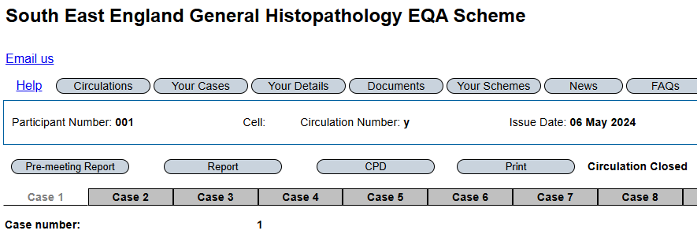
Please note, participants who have not returned a signed scheme agreement form, or who have not paid their subscriptions within 6 months of invoice issue, will not receive personalised results or a certificate of participation.

Suspending participation
If you wish to suspend your membership due to sabbatical or maternity leave, please email the Scheme administrator.

Seeking Help with EQALite
There is a Frequently Asked Question Tab
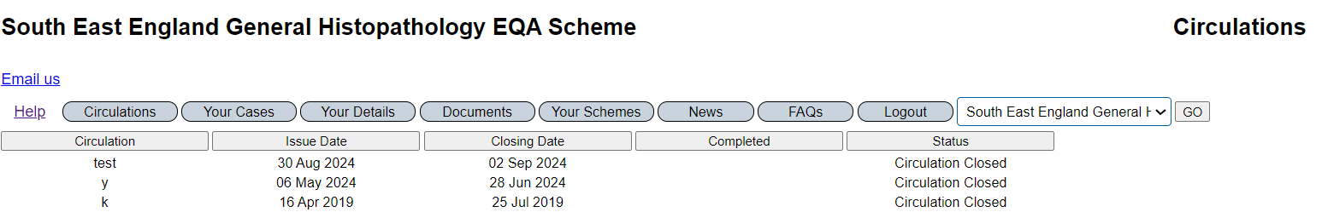
Select the relevant issue.
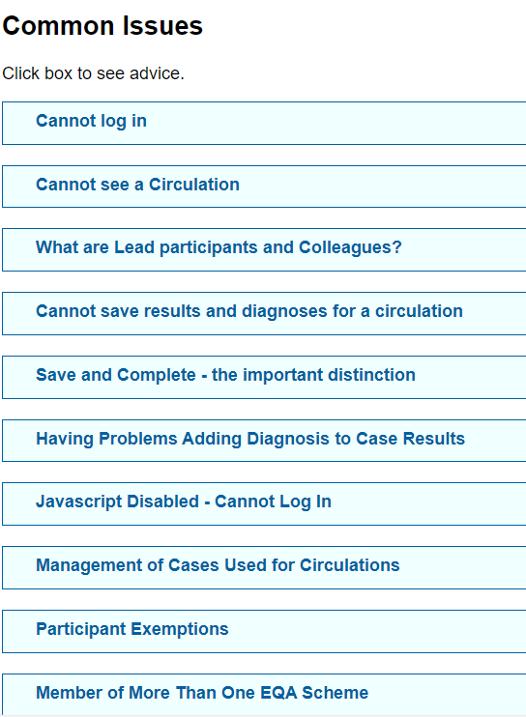
If this does not answer your question, please email the EQA office mtw-tr.EQA@nhs.net and amend the subject line to reflect your problem. Attaching a screenshot of the problem would be most helpful.

Return to top of document

Multiple diagnoses on the same line will be scored separately to single diagnoses and are liable to be scored poorly compared to those entering the same two diagnoses on separate lines, unless the consensus is that there are multiple diagnoses in the same case.

