Data Protection Impact Assessment

Document Owner | Version | Status | Approved by | Issue Date

Document management

Revision History

Version | Date | Summary of Changes

Data Protection Impact Assessment (DPIA) screening questions
The following questions must be answered fully to determine the need for a DPIA .
Project Name
AIC Diabetes West Kent Community Model

Project Sponsor
Steve Orpin, MTW/Adam Wickings, West Kent CCG

Project Manager
Joint PMO Lead, MTW

Will the project involve the collection of new information about individuals?
No

Will the project compel individuals to provide information about themselves?
Yes

Will information about individuals be disclosed to organisations or people who have not previously had routine access to the information?
No

Are you using information about individuals for a purpose it is not currently used for, or in a way it is not currently used?
No

Does the project involve you using new technology which might be perceived as being privacy intrusive? For example, the use of biometrics or facial recognition.
No

Will the project result in you making decisions or taking action against individuals in ways which can have a significant impact on them?
No

Is the information about individuals of a kind particularly likely to raise privacy concerns or expectations? For example, health records, criminal records or other information that people would consider to be particularly private.
Yes

Will the project require you to contact individuals in ways which they may find intrusive?
No

If answering ‘Yes’ to any of the questions it is likely a DPIA is required.

Data Protection Impact Assessment

Step one: Identify the need for a DPIA

Explain broadly what the project aims to achieve and what type of processing it involves. You may find it helpful to refer or link to other documents, such as a project proposal. Summarise why you identified the need for a DPIA.

Background

Diabetes is acknowledged as a major public health challenge. There is an increase in prevalence of diabetes in the UK from 2.4% in 1994 to 5.8% in 2012 and the rising trend is predicted to continue from the current 3 million to nearly 5 million diabetic patients by 2025.

For West Kent this will mean a rise from 20,485 to 34,140 people with diabetes in the next 10 years and there is currently no planned increase in primary care capacity to meet this rise in demand. There is also significant variance in existing primary care provision. It is estimated that only 25% of Type 1 patients and 41% of Type 2 patients receive all 8 care processes recommended by NICE.

Diabetic related preventable non-elective acute admissions are also on the rise and consuming a lot of resources. Diabetes and its related disorders consumed nearly £23.7 billion from the NHS budget (18.3%) in 2014 and is set to rise to £39.8 billion by 2035. For West Kent CCG this relates to nearly £87 million spent in 2014.

Service re-design

The issues above highlight a clear case for change, to redesign the current care pathway under a single integrated service model, with the following features:

- MTW lead the service and sub-contract stakeholders such as West Kent Health Ltd (also known as the West Kent GP federation) and KCHFT.

Increased investment of £139k to provide psychological support, manage housebound patients, extend level 2 coverage and additional professional education.

Upskilled and supported primary care to better manage diabetes.

Referrals are to be triaged by diabetes specialist nurse (DSN) to ensure patients are directed to the most appropriate clinician.

Services to be provided from a combination of hubs and spokes in which:

Spokes are an expansion of the existing Local Enhanced Service aligned to a population size of 40,000-60,000 providing services for Type 2 diabetes patients with in-reach DSN support.

Hubs are a variation of the existing MTW services providing specialist led services for Type 1 diabetes patients from two sites (Abbey Court and Paula Carr).

The key elements below encompass the combined responsibilities of Maidstone & Tunbridge Wells NHS Trust in partnership with West Kent Health Ltd, West Kent CCG and KCHFT.

Project objectives

The objective of the project is to ensure that MTW and West Kent CCG are able to collaborate, develop and implement a new integrated Diabetes service to deliver quality of care to our patients. For the purpose of this project the following will be undertaken:
- Seek to understand the workforce implications and develop a training programme accordingly.
- Improve primary care capability through structured training and education and peer support
- Develop an integrated workforce which is fit for the present and future needs of our diabetic population.
- Generate clinical guidelines for primary care.
- Model new ways of working with clear process map and boundaries.
- Revise Standard Operating Policy and produce plan(s) to deliver this change programme.
- Create an IT vision and road map.
- Set clear KPIs and automated methods in capturing business intelligence to allow for a proactive response to any deviation from the desired target.
- Improve patient experience by increasing access to improved services delivered, i.e. care closer to home.

Project scope and exclusions
The project scope will include the delivery of the objectives in both primary and secondary care in relation to diabetic patients. A key enabler to the project will be the implementation of technology to support the objectives.

Technology Enablers

- A comprehensive IT solution is required to allow clinicians to find, read and update any patient record quickly and easily. Where a spoke practice needs the support of a Trust DSN or Consultant, the DSN or Consultant should have the ability to review the patient’s complete record in order to provide that support. Conversely, where a patient is transferred from the hub back to a spoke, the patient record will be automatically updated with the relevant information.

Key features
- Referrals triaged at a single point of access by a Diabetes Specialist Nurse to ensure patients are directed to the most appropriate clinician.
- All Type 2 diabetes patients will be managed by an upskilled Primary Care organised into clusters co-ordinated by the GP Federation.
- All Type 1 diabetes, young adults, preconception planning and follow-ups to non-elective admissions will be managed by secondary care.
- Level 2 practices will have access to EDEN (Effective Diabetes Education Training Now) training courses delivered by MTW staff, and access to DSN and Consultant support.

Key stakeholders

- Consultant Diabetologist and Clinical Lead (MTW)
- Diabetes Specialist Nurse (MTW) & Lead Dietician (MTW)
- AGM Diabetes (MTW)
- GP and Management Representative from West Kent Health Ltd
- Head of Community Nursing (KCHFT)
- Head of Podiatry (KCHFT)
- IT lead from WKCCG
- Commissioning Manager (WKCCG)
- Programme Support (MTW and WKCCG)

A DPIA is required as patient health data, via referrals, is being shared and processed by upskilled primary care providers employed by the GP federation. The data collected and processed is broadly the same as per the current service – the communities diabetes requires the introduction of new systems to allow referral, triage and appointment booking in hub and spoke locations and use individual GP clinical systems to be the primary data source. The individual systems will use a software package to provide a single federated view of all patients in West Kent, with the ability write back the outcome of a diabetes service encounter to a patient’s registered GP practice system.

Reporting and analysis will also be required to support operational process, monitor the delivery of outcomes and key KPIs and shape further development of the service (e.g. clinical and operational effectiveness and service delivery efficiency)

Step two: Describe the information flows
Describe the nature of the processing: How will you collect, use, store and delete data? What is the source of the data? Will you be sharing data with anyone? You might find it useful to refer to a flow diagram or another way of describing data flows. What types of processing identified as likely high risk are involved?

The community diabetes service will be utilising two systems:

- eRS: to manage the incoming referrals and the clinical triage process
- Vision 360: provides appointment booking in hub and spoke locations and access to the primary care patient records residing in individual GP practice systems

In addition the administrative of service will require the use of office application (Excel, Word) to produce patient letters and manage workflow through worklists.

e-Referral Service (eRS)

eRS is a nationally provided NHS system to manage referrals electronically. The project proposes to use the Referral Assessment Service (RAS) capabilities of eRS: https://digital.nhs.uk/services/nhs-e-referral-service/the-future-of-the-nhs-e-referral-service/referral-assessment-services. eRS will provide the front door to the service for referrers and enable clinical triaging by DSNs so patients are directed to the most appropriate service. eRS provides the workflow functionality to ensure referrals are manage correctly.

Vision 360

Vision 360 is hosted as a secure cloud service under the auspices of the national GP Systems of Choice (GPSoC) framework agreement.

Vision 360 provides two capabilities:
- Appointment booking: Provides a share appointment book for hub (Maidstone Hospital and Abbey Court) and spoke clinics held in West Kent GP practices. Appointments will be arranged with patients by the administration team supporting the service. The appointment book will be accessible by the health professionals delivering the service and the administration team
- Federated access to primary care patient records: Patients records will need to be available to health professionals delivering the service to patients – records will need to be reviewed as part of the triage process and when seeing patient in clinic. At the end of a patient encounter with a clinician (practice nurse, DSN or consultant), the outcome of the consultation will be recorded and saved to the patient record at the host practices. Vision 360 ‘steams’ data from all practice systems (EMIS/Vision) in West Kent and makes this available through a single application (Vision Anywhere) which will be installed in GP practices and MTW locations.

There are currently no data transfer interfaces between eRS and Vision 360.

The diagram below sets out the data flows associated with the service’s agreed business processes.
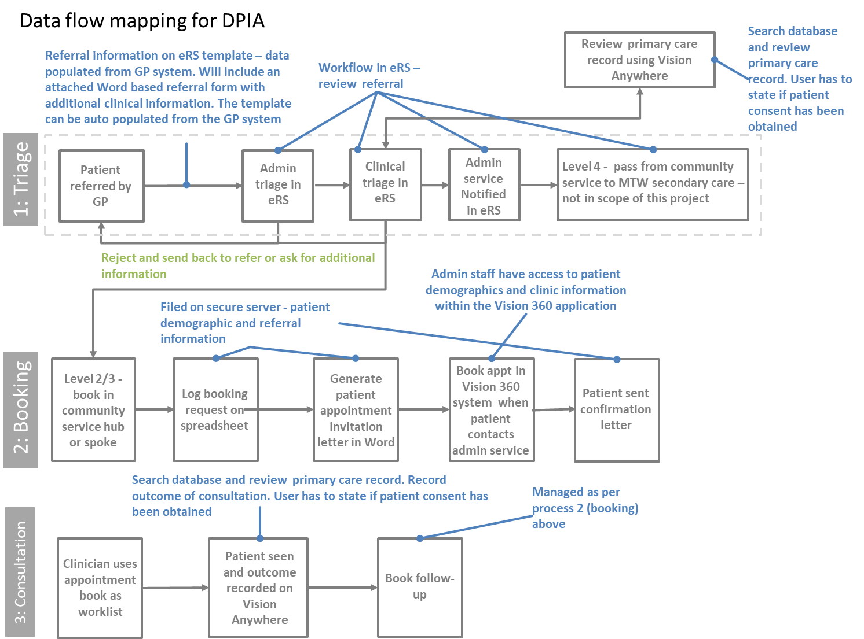

The diagram below summarises how users will interact with IT systems.

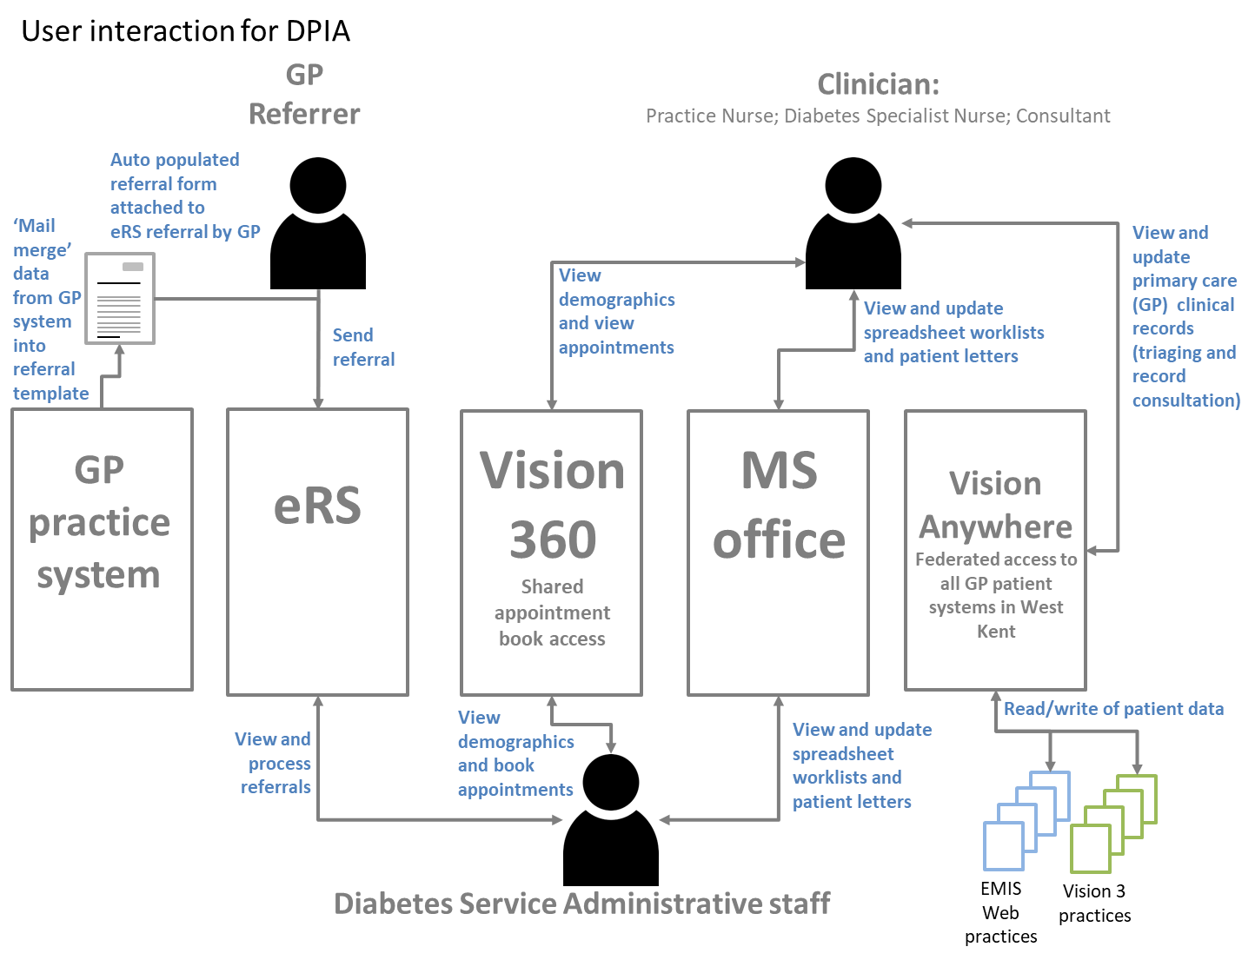

Data sharing agreements

Vision 360 is manage by the West Kent GP Federation and there are two governance controls in place to manage data:
- Data Sharing Agreement – signed agreement by West Kent CCG practices to allow data to be “streamed” from individual practice systems to the Vision 360 environment. Vision 360 does not stream data that is deemed to be sensitive and the agreement provides details of the Read codes that will not extracted from GP practice systems
- Data Access agreement - access to data for specific uses is managed by an access request from. The form is completed by the service requiring access to patient records in Vision 360. Access is approved by the GP Federation GPIT Steering Group.

Describe the scope of the processing: What is the nature of the data and does it include special category or criminal offence data? How much data will you be collecting and using? How often? How long will you keep it? How many individuals are affected? What geographical area does it cover?

The type of data collected is special category data personal information about health, care and wellbeing.

The main data sets required:

- Minimum data required for referral
- Data required for triaging
- Data required to book an appointment
- Data collected at a consultation with a patient.

The form embedded below sets out the datasets that will be collected as part of service delivery.
Data is managed in line with the code of practice for records management for health and social care 2016.

The service covers all Type 1 and Type 2 diabetic patients registered in West Kent CCG registered GP Practices, that require Level 2 or Level 3 management, and are referred into the service by their GP.

Data collected by the service will become part of patients’’ long term primary care record and will be retain in line with legalisation, policy and good practice as applied to GP practices.

Describe the contact of the processing: What is the nature of your relationship with the individuals? How much control will they have? Would they expect you to use their data in this way? Do they include children or other vulnerable groups? Are there prior concerns over this type of processing or security flaws? Is it novel in any way? What is the current state of technology in this area? Are there any current issues of public concern that you should factor in? Are you signed up to any approved code of conduct or certification scheme (once any have been approved)?

Who is the data controller and processor?

Data controllers:

- eRS: NHS England
- Patient records in Vision 360: individual GP practices
- Appointments: West Kent GP federation

Data processors:

- Vision 360: In Practice Systems as application service provider
- Maidstone and Tunbridge Wells as employer of DSNs and clinical consultants
- GP practices as employers of GPs and practice nurses

How much say do the patients have?

Data processing is part of delivery of direct healthcare services.

What have patients been told about the service and who will be accessing their records?

All GP practices have information about what records are shared within their individual privacy notices. Patient will also be informed by the GP when referred into the service.

What information is provided to young adults and other vulnerable patient groups i.e., learning disability?

Concerns re data flows i.e., inappropriate access to records, access controls, privacy alerts.
Technology – established – audit logs, access controls,

Vision access controls
User access to Vision 360 is managed by unique usernames and passwords. These are issued to authorised users. Users can only logon to the services that are appropriate to their role e.g. are they clinical (view patients records) or administrative (view referrals and booking system only). When clinicians needs to access patient records there asked if they have consent or another legitimate reason to access the records. This is logged and privacy officer alerts are triggered if required. System access is logged for audit purposes.

When a consultation is saved in Vision Anywhere the patient’s registered practice is notified so that can review the data before it is applied to the patient records.

eRS access controls

eRS is a nationally provided service and access is controlled via Smartcards.

The approach used by the project is not deemed as ‘novel’ as it based on using existing technologies.

No public concern issues

Everyone party to the data is compliant with the Data Protection and Security Toolkit, ISO 27001 or equivalent. MTW is working towards Cyber Essentials Plus.

Describe the purposes of the processing: What do you want to achieve? What is the intended effect on individuals? What are the benefits of the processing for you, and more broadly?

The objective of the project is to ensure that MTW and West Kent CCG are able to collaborate, develop and implement a new integrated Diabetes service to deliver quality of care to our patients.

Desired outcomes/Success Criteria

The expected outcome/success criteria noted below:

- Achieve key objectives within the timeline identified within the action plan.
- Improved achievement of all 9 care processes for Type I diabetic patients (Detail to be quantified during the analysis phase.)
- Improved achievement of all 9 care processes for Type II diabetic patients (Detail to be quantified during the analysis phase.)
- Reduction in diabetic complications emergency admissions (Detail to be quantified during the analysis phase)
- Reduction in diabetic prescribing costs (Detail to be quantified during the analysis phase)
- Increased patient satisfaction (Detail to be quantified during the analysis phase)
- Improved access to psychological support for diabetic patients (Detail to be quantified during the analysis phase)
- Primary Care take up of EDEN training for diabetes management (Detail to be quantified during the analysis phase)
- DERIK training provision for diabetic patients (Detail to be quantified during the analysis phase)
- DAFNE training provision for diabetic patients (Detail to be quantified during the analysis phase)
- Technology interface between new technology enablers.

Step 3: Consultation requirements
Consider how to consult with relevant stakeholders: Describe when and how you will seek individual’s views – or justify why it is not appropriate to do so. Who else do you need to involve within the Trust? Do you need to ask your processors to assist? Do you plan to consult information security experts, or any other experts?

Describe when and how you will seek individual’s views – or justify why it is not appropriate to do so.

The project is being overseen by the Diabetes Implementation Group which is comprised of clinical, managerial and administrative staff from all stakeholder organisations (the CCG, MTW, GP Federation, KCHFT). All aspects of the service’s design, development and implementation is managed by the DIG. Members are expected to consult with relevant colleagues in their respective organisations.

Step 4: Assess necessity and proportionality
Describe compliance and proportionality measures, in particular: What is your lawful basis for processing? Does the processing actually achieve your purpose? Is there another way to achieve the same outcome? How will you prevent function creep? How will you ensure data quality and data minimisation? What information will you give individuals? How will you help to support their rights? What measures do you take to ensure processors comply? How do you safeguard any international transfers?

Providing healthcare and related services

Legal grounds:
- the use is necessary for compliance with a legal obligation to which the Trust is subject
- the use is necessary for the performance of a task carried out in the public interest or in the exercise of official authority vested in the controller e.g. in order to provide you or another with healthcare services

Additional legal grounds for sensitive personal information/special categories of personal data:
- the use is necessary for the purposes of preventive or occupational medicine, medical diagnosis, the provision of health or social care or treatment or the management of health or social care systems and services
- processing is necessary for reasons of public interest in the area of public health, such as ensuring high standards of quality and safety of health care
- You have given explicit consent.

Administration and management of healthcare services (such as maintaining records, receiving professional advice)

Legal grounds:
- the use is necessary for the performance of a task carried out in the public interest or in the exercise of official authority vested in the controller e.g. in order to provide you or another with healthcare services

Additional legal grounds for sensitive personal information/special categories of personal data:
- the use is necessary for the purposes of preventive or occupational medicine, medical diagnosis, the provision of health or social care or treatment or the management of health or social care systems and services
- The use is necessary in order for us to establish, exercise or defend our legal rights.

Service improvement, evaluation and audit (in order to improve the healthcare services that the Trust and others provide, and to protect and improve the health of the public)

Legal grounds:
- the use is necessary for the performance of a task carried out in the public interest or in the exercise of official authority vested in the controller e.g. in order to provide you or another with healthcare services

Additional legal grounds for sensitive personal information/special categories of personal data:
- we need to use the information for reasons of substantial public interest
- the use is necessary for the purposes of preventive or occupational medicine, medical diagnosis, the provision of health or social care or treatment or the management of health or social care systems and services
- the use is necessary for reasons of public interest in the area of public health, such as ensuring high standards of quality and safety of health care

Data quality assurance?

Where possible data entry templates will be used to ensure the correct datasets are collected at each stage in the referral, triaging and consultation processes. The proposed template for collecting datasets has been embedded in an earlier section of this document.

Step 5: Identify and assess risks
Describe the source of risk and nature of potential impact on individuals. Include associated compliance and corporate risks as necessary.

Risk | Likelihood of harm | Severity of harm | Overall risk
 | Remote, possible or probable | Minimal, significant or severe | Low, medium or high
Inappropriate access | Remote | Significant | Low
Disclosure in error | Remote | Significant | Low
Cyber threats | Remote | Significant | Low
Corruption of data | Remote | Significant | Low
Add additional rows as required.

Step 6: Identify measures to reduce risk
Identify additional measures you could take to reduce or eliminate risks identified as medium or high risk in step 5.
Risk | Options to reduce or eliminate risk | Effect on risk | Residual risk | Measure approved
 |  | Eliminated, reduced or accepted | Low, medium or high | Yes/no
 | Access controls | Reduced | Low
 | Training | Reduced | Low
 | Cyber security | Reduced | Low
 | Backups | Reduced | Low
Add additional rows as required.

Contact points for future privacy concerns

Kevin Rowan, Secretary to the Board and Data Protection Officer, MTW

