Annual Report and Accounts
for the year ended 31 March 2017

Charity Number 1055215

Contents

Annual Report for the year ended 31 March 2017 | 3
Trustee Statement | 3
Information about the charity | 3
The Corporate Trustee | 4
Principal Advisors | 5
Governance and Management of the Charity | 6
Aims and Objectives for the Public Benefit | 8
Investment Performance | 9
Achievement of Public Benefit | 10
Expenditure | 10
Income | 13
Looking Forward | 14
Statement of Trustee Responsibilities in Respect of the Trustee Annual Report and the Financial Statements | 16
Independent Auditors’ Report to the Trustee of Maidstone and Tunbridge Wells NHS Charity | 17
Statement of Financial Activities for the Year Ended 31 March 2017 | 19
Balance Sheet as at 31 March 2017 | 20
Statement of cash flows as at 31 March 2017 | 21
Notes to the Financial Statements for the Year Ended 31 March 2017 | 22
Maidstone and Tunbridge Wells NHS Trust Charity Donation form | 35

Annual Report for the year ended 31 March 2017

The Corporate Trustee (Trustee) presents the Maidstone and Tunbridge Wells NHS Trust Charitable Funds (the Charity’s) annual report and the audited financial statements for the year ended 31 March 2017.

The financial statements set out on pages 19 to 32 comply with the charity’s trust deed, applicable Accounting Standards in the United Kingdom and the Statement of Recommended Practice (SORP) relevant to charities preparing their accounts in accordance with the Financial Reporting Standard applicable in the UK and Republic of Ireland (FRS 102) (effective 1 January 2015).

Trustee Statement

The generosity of the many people who have raised funds, given donations and made provisions in their will, is recognised by both the Trustee and staff. The Trustee and the staff would like to express their sincere gratitude to all those who have made a contribution which has enabled the Charity to enhance the standard of care, services and facilities provided by the Maidstone and Tunbridge Wells NHS Trust to patients, their relatives, visitors and staff.

The role of the Charity

The Maidstone and Tunbridge Wells NHS Trust (‘the Trust’) is the Corporate Trustee of the charitable fund under paragraph 16c of Schedule 2 of the NHS and Community Care Act 1990. The Charity is constituted by a Trust Deed and registered with the Charity Commissioners under charity number 1055215, and includes funds in respect of the hospitals of the Maidstone and Tunbridge Wells NHS Trust.

During the year the Charity was situated on two main sites at Maidstone and Pembury in Kent. These are Maidstone Hospital and The Tunbridge Wells Hospital at Pembury.

The Charity is a ‘NHS Umbrella Charity’ under which there are individual sub-funds that are held for administrative purposes, principally to respect the wishes of the donors.

Within the Umbrella there were a total of 39 individual funds at the 31st March 2017 with a total value of £1,200k. The number of funds in each category is as follows:-
- 16 restricted funds.
- 2 endowment funds (capital in perpetuity) - only the net income to be spent, whilst the capital remains invested.
- 21 unrestricted or designated Funds created for donations received for use by hospitals, wards and departments to reflect donors’ wishes. These do not form a binding trust.

The major funds within each of these categories are disclosed in Note 8 in the accounts.

The Corporate Trustee
Maidstone and Tunbridge Wells NHS Trust is the Corporate Trustee of the Charity.
The Trust Board effectively adopts the role of Trustee as defined by the Charity Commission (it is considered to be the agent of the Trustee). Individual members of the Trust Board are not trustees under Charity Law.
Details of appointments and terminations within the financial year are tabled below:
Executive Directors | Non-Executive Directors | Other Directors
Glenn Douglas – Chief Executive | Anthony Jones – Chairman of Trust Board (until 28 Feb 2017)  David Highton – Chair of Trust Board (from 8th May 2017) | Sara Mumford – Director of Infection Prevention and Control
Stephen Orpin – Director of Finance | Steve Tinton – Chair of Charitable Funds Committee (until 28 Sept 2016)
Jim Lusby – Deputy Chief Executive | Sarah Dunnett OBE
Paul Sigston – Medical Director (until 8 Feb 2017)  Peter Maskell – Medical Director (from 8 Feb 2017) | Kevin Tallett
Angela Gallagher – Chief Operating Officer | Sylvia Denton CBE (until 28 Feb 2017)
Avey Bhatia – Chief Nurse  (until 31 Jan 2017)  Claire O’Brien – Interim Chief Nurse (from 28 Feb 2017) | Alex King MBE
Richard Hayden – Director of Workforce
None of the Members of the Trust Board have received any remuneration from the Charity in this financial year for work relating to their responsibilities for the Charity as agent of the Corporate Trustee. (2015/16 none)

The principal office of the Charity is:

Trust Headquarters, Maidstone and Tunbridge Wells NHS Trust
Maidstone Hospital
Hermitage Lane
Maidstone
Kent ME16 9QQ
Principal advisors:

External Auditor  Grant Thornton UK LLP  Grant Thornton House  Melton Street  London  NW1 2EP | Bankers  National Westminster Bank  Kent Corporate Business Centre  PO Box 344  Maidstone  Kent ME14 1AT
Solicitors  Brachers Solicitors  Somerfield House  59 London Road  Maidstone  Kent ME16 8JH | Bankers  Scottish Widows  67 Morrison Street  Edinburgh  EH3 8YJ
Solicitors  Capsticks Solicitors LLP  1 St George’s House East  St George’s Road  Wimbledon, London  SW19 4DR | Bankers  Santander Business Banking  Bridle Road  Bootle  Merseyside  L30 4GB
Investment Managers  Charities Aid Foundation  25 Kings Hill Avenue  Kings Hill  West Malling  Kent ME19 4TA | Bankers  Clydesdale Bank  6/8 London Road  Unit 5  Peveril Court  Crawley  RH10 8JB
Bankers
National Westminster Bank PLC (RBS/GBS)
2nd Floor
280 Bishopsgate
London
EC2M 4RB

Governance and Management of the Charity

Governance

The Board of the Maidstone and Tunbridge Wells NHS Trust became responsible for the funds with effect from the 1 April 2000, following the merger of the Kent and Sussex Weald NHS Trust, which was based at Tunbridge Wells and the Mid Kent Healthcare Trust, which was located at Maidstone. The Trust Board delegates the daily stewardship of the funds to the Charitable Funds Committee of the Trust, which within its annual programme of meetings, includes relevant training and updates as required to assist in the performance of its role as Trustee.

The Charitable Funds Committee plans to meet at least three times a year.

The proceedings and decisions of the committee are recorded. The minutes of each meeting are formally agreed by the Chair of the Committee and circulated to all members.

Recruitment and Training of Trust Board and Committee Members

All Trust Board and Committee members undertake an induction programme within the Trust upon joining. They are also able to focus on a particular area of the Trust in which they have a special interest or concern.

Management of the Charity

The Charitable Funds Committee has a tightly controlled scheme of authorisation in place in order to spend the funds. This is achieved by delegating the day to day expenditure to the duly authorised fund holders. The fund holders consist mainly of senior department managers. Each individual fund holder is approved by the general manager or Clinical Director of the Directorate, and also made aware of the Trust’s Standing Orders and Standing Financial Instructions, that apply to Charitable Funds. Each fund holder receives a detailed financial statement of the fund each month.

Risk Management

The major risks to the Charity have been assessed, and in the opinion of the Corporate Trustee, all necessary action has been taken and procedures have been put in place to minimise those risks wherever possible. The risk policies and financial controls of the Trust also apply to the Charitable Funds. The Corporate Trustee has identified that the main area of financial risk for the Charitable Funds is the performance of the investments.

To mitigate the risk of investment performance the Corporate Trustee has adopted a relatively low risk policy, but 50% of funds will remain exposed to those risks normally associated with investing in stocks and shares and regarded as medium to long term investment. The cash balances will be invested in bank accounts which have a low credit risk and are covered by the Financial Services compensation scheme up to a maximum of £85,000 per banking institution operating under a separate banking licence. Our policy is that the maximum investment is up to £85,000 in each banking institution outside the Government banking Scheme. Therefore there is no risk on these investments.

Investment Powers

The investment powers of the charitable fund are stated in the Declaration of Trust registered with the Charity Commission, which provides for the following:

‘‘to invest the trust fund and any part thereof in the purchase of or at interest upon the security of such stocks, funds, securities or other investments of whatsoever nature and where so ever situate as the trustee in their discretion think fit but so that the trustee:

- shall exercise such power with the care that a prudent person of business would in making investments for a person for whom he felt morally obliged to provide;

- shall not make any speculative or hazardous investment (and, for the avoidance of doubt, this power to invest does not extend to the laying out of money on the acquisition of futures and traded options);

- shall not have power under this clause to engage in trading ventures; and

d) shall have regard to the need for diversification of investments in the circumstances of the Charity and to the suitability of proposed investments.’’

Investment strategy

The investment strategy of the charity is defined, by the charitable fund committee on behalf of the corporate trustee as follows:

“to maximise total returns whilst minimising any risk to the total value of the fund in both the short to medium term.”

The strategy identifies the current preferred investment mix for the charity as:

- 50% Cash;
- 25% Equities; and
- 25% Bonds.

The Charitable Funds Committee monitors the performance of the investments on a regular basis.

Professional Advisors

The External Audit is performed by Grant Thornton UK LLP. For the 2016/17 financial year, an independent examination will be carried out due to the charity’s gross income falling below £1m.

In addition, TIAA, the internal auditors of the Trust, review on a planned basis the systems and procedures put in place by the Corporate Trustee.

Aims and Objectives for the Public Benefit

The key objective of the Trustee of the Maidstone and Tunbridge Wells NHS Charity is to ensure that donations and legacies received are used in accordance with the wishes of the donor and the aims of the Trust. The Trustees therefore consider that the charity clearly falls within the definition of a public benefit entity under the terms of FRS 102.

The Corporate Trustee confirms that the guidance provided by the Charity Commission has been referred to with regard to the need for public benefit when reviewing their aims and objectives and future activities.

The purpose of the Charity is to provide benefit to the public by supporting the prevention and treatment of illness in all its forms and to promote research and education in healthcare through:

- Improving the patient and carer experience;
- Improving healthcare facilities and equipment;
- Facilitating high quality research programmes;
- Encouraging and supporting innovation in the development of services; and
- Supporting the training, personal development and welfare of staff.

The objects of the umbrella Charity are stated in the Trust deed as follows:-

“The Trustee shall hold the trust fund upon trust to apply the income, and at their discretion, so far as may be permissible, the capital, for such purposes relating to Hospital Services (including Research); or to any other part of the Health Service associated with any hospital as the Trustee think fit.”

The restricted funds have individual specified purposes that govern their use, in conjunction with the objects of the umbrella Charity.

Strategy for Achieving its Objectives

The Charitable Funds are used to support the overall objectives of the Trust, and include the provision of a wide range of equipment and facilities for both patients and staff. This allows the Trust to develop its services through new equipment and facilities and to provide training for staff which enhances their skills and knowledge allowing them to improve their contribution to the provision of its services to the public benefit.

The development of the Trust’s services may be dependent on both the Charitable Funds and the funds received from the Exchequer. This interdependency provides opportunities for the Charity to contribute to services which make a greater impact than the cash sum would make on its own.

Reserves and Commitments

Charity Reserves as defined by Charities SORP (FRS 102) are those funds which become available to the charity to be spent at the Trustee’s discretion in furtherance of the charity’s objectives, excluding funds which are spent or committed or could only be realised through the disposal of fixed assets. These are therefore classified as ‘free’.

The Corporate Trustee has not made any changes to policy during the year and still requires that commitments against each fund are made only when the resources needed are available.

Major items of expenditure for both goods and services are agreed in advance in order that the necessary liquid resources can be released from the Investment Managers on a planned and timely basis. None of the funds held by the Investment Managers are committed on a long term basis as the Corporate Trustee has a policy to put the funds to the best possible use as quickly as is reasonably possible, taking into consideration any particular restrictions imposed by individual donors.

Investment Performance

Investment income for the year was £21k (2015/16 £23k). In the current economic climate this is considered to indicate an acceptable performance for an investment strategy based on a low risk portfolio of investments. The total performance return on the portfolio of the investments (equity and bond) was a gain of £50k which equates to 8.67% on the opening portfolio value (2015/16 3.49% loss). This reflects an improvement in market performance compared with the previous year. The Trustee continues to review its investment strategy to seek to maximise its resources whilst maintaining liquidity and security of assets.

The value of equities and bonds varies according to market forces with the CAF bonds and equities portfolio increasing in market value to £627k at 31 March 2017 (£577k at 31 March 2016). The cash investment at 31 March 2017 was £1,081k (£1,514k at 31 March 2016).

The current asset portfolio of cash and investment allocation totalling £1,708k at 31 March 2017 is shown in the following graph:

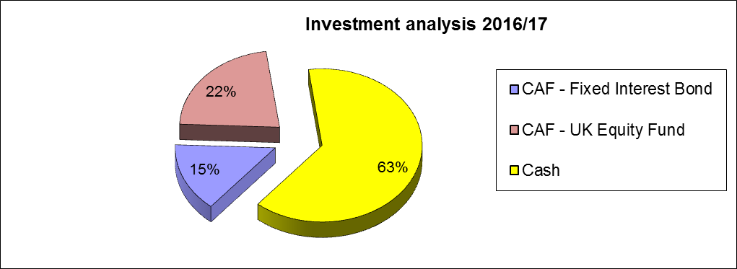

The cash allocation at 63% exceeds the strategy of Cash of 50% due to the high level of legacy received in 2015/16 with matching plans to spend it in 2016/17.The plan to spend the legacies is still ongoing for 2017/18. As these plans are realised the level of cash held will reduce down to the level set out in the strategy. Consequently, the mix of bonds (15%) and equities (22%) is lower than the planned strategy. The bond and equity investments have performed better than the previous year, although equity investments continue to perform better than bond investments over time.

The graph below demonstrates the performance of the bonds and equities since their purchase in December 2011.

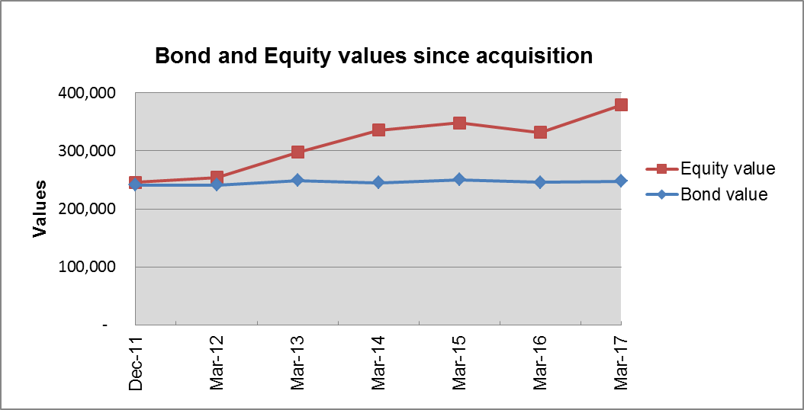

Performance of the portfolio is monitored and reviewed by the Charitable Funds Committee.

Achievement of public benefit

The Trust has achieved its objectives to enhance services and amenities for the public both as patients and visitors as well as staff through the purchase of equipment and support for projects.

The graph below shows that in this financial year for every £1 raised, 94 pence was spent in achieving the objectives of the charity. This is slightly higher than the equivalent ratio for 2015/16 (93 pence), it can be a useful guide to both donors and the corporate trustee.

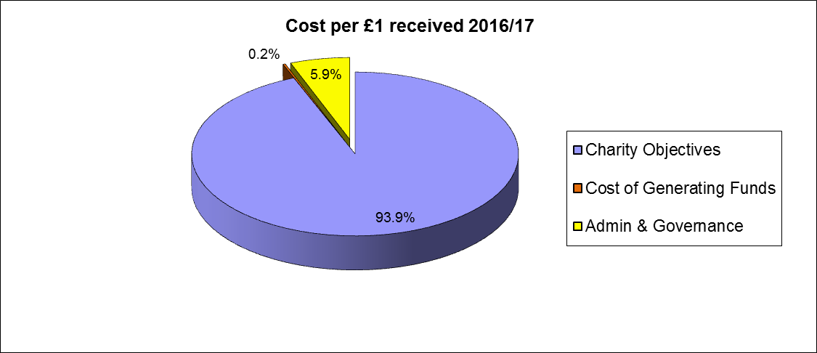

Expenditure

Total resources expended by the Charity within this financial year were £866k (2015/16 £795k), of which £785k (91%) was a contribution to Maidstone and Tunbridge Wells NHS Trust (2015/16 £700k, 88%), £14k spent directly on patient welfare, £65k on staff amenities which primarily was for further staff training to enhance the quality of patient care and £2k on investment fees. Note governance cost of £51k is included in total contribution to NHS. The governance costs include the internal management fees for administering the funds. The fees are agreed each year by the Trustees. These costs are charged proportionately across the individual funds on a quarterly basis.

The following graph provides an analysis and comparison with previous years:

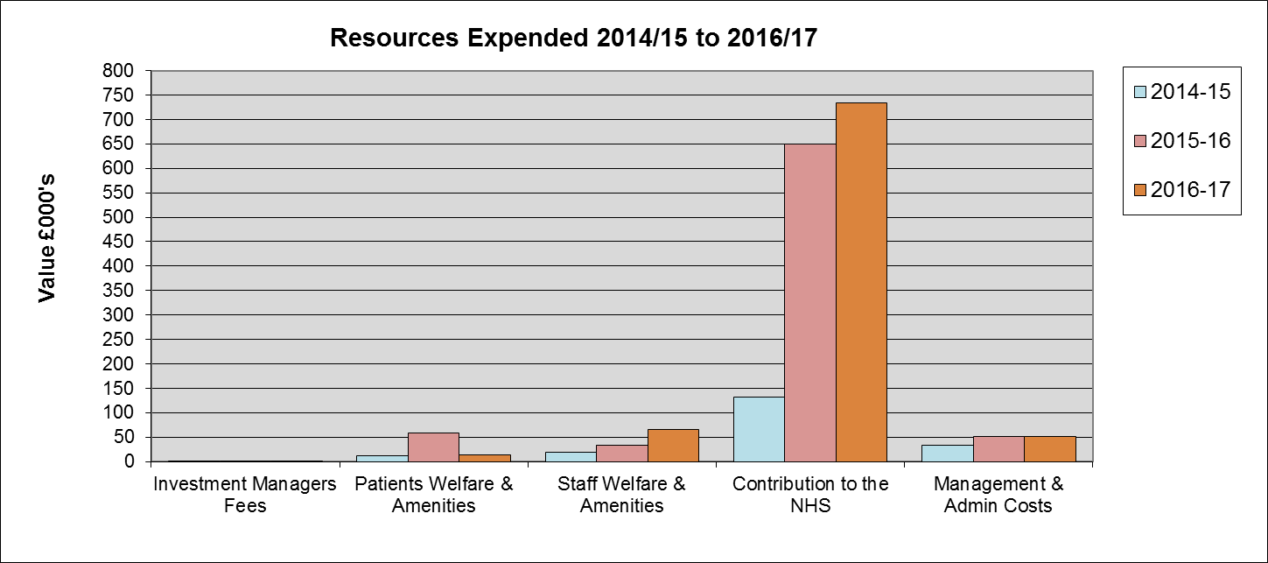

Charitable expenditure for the year is detailed below.
Medical Equipment – Total spend £497k (2015/16 £608k)

Medical equipment has been purchased within the reporting year to provide additional resources to enhance the quality of treatment, services and amenities within the Trust.

The most significant purchases were:

- Additional Echo Machine funded by Mollie Hayling Legacy (£129k)
- EPIQ Ultrasound System funded by Mollie Hayling Legacy (£150k)
- 2 Cardiographs funded by the David Crow Legacy (14k)
- 3 Ultrasound Probes (£18k)
- Automated Dose Dispenser (£13k)

Insufflator for Theatres at TWH | Bladder Scanner each for Oncology at Kent & Canterbury and Maidstone
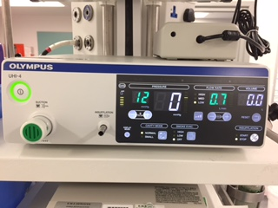 | 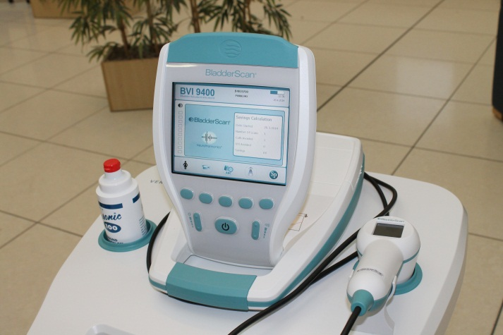

Cardiology Ultrasound for TWH Cardiology, Department (Mollie Hayling Legacy) | ECG machines for Cardiology Department at Maidstone (David Crow Legacy)
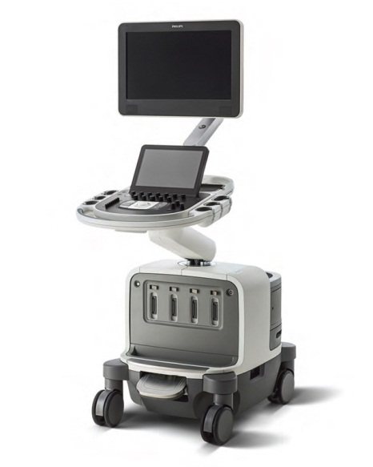 | 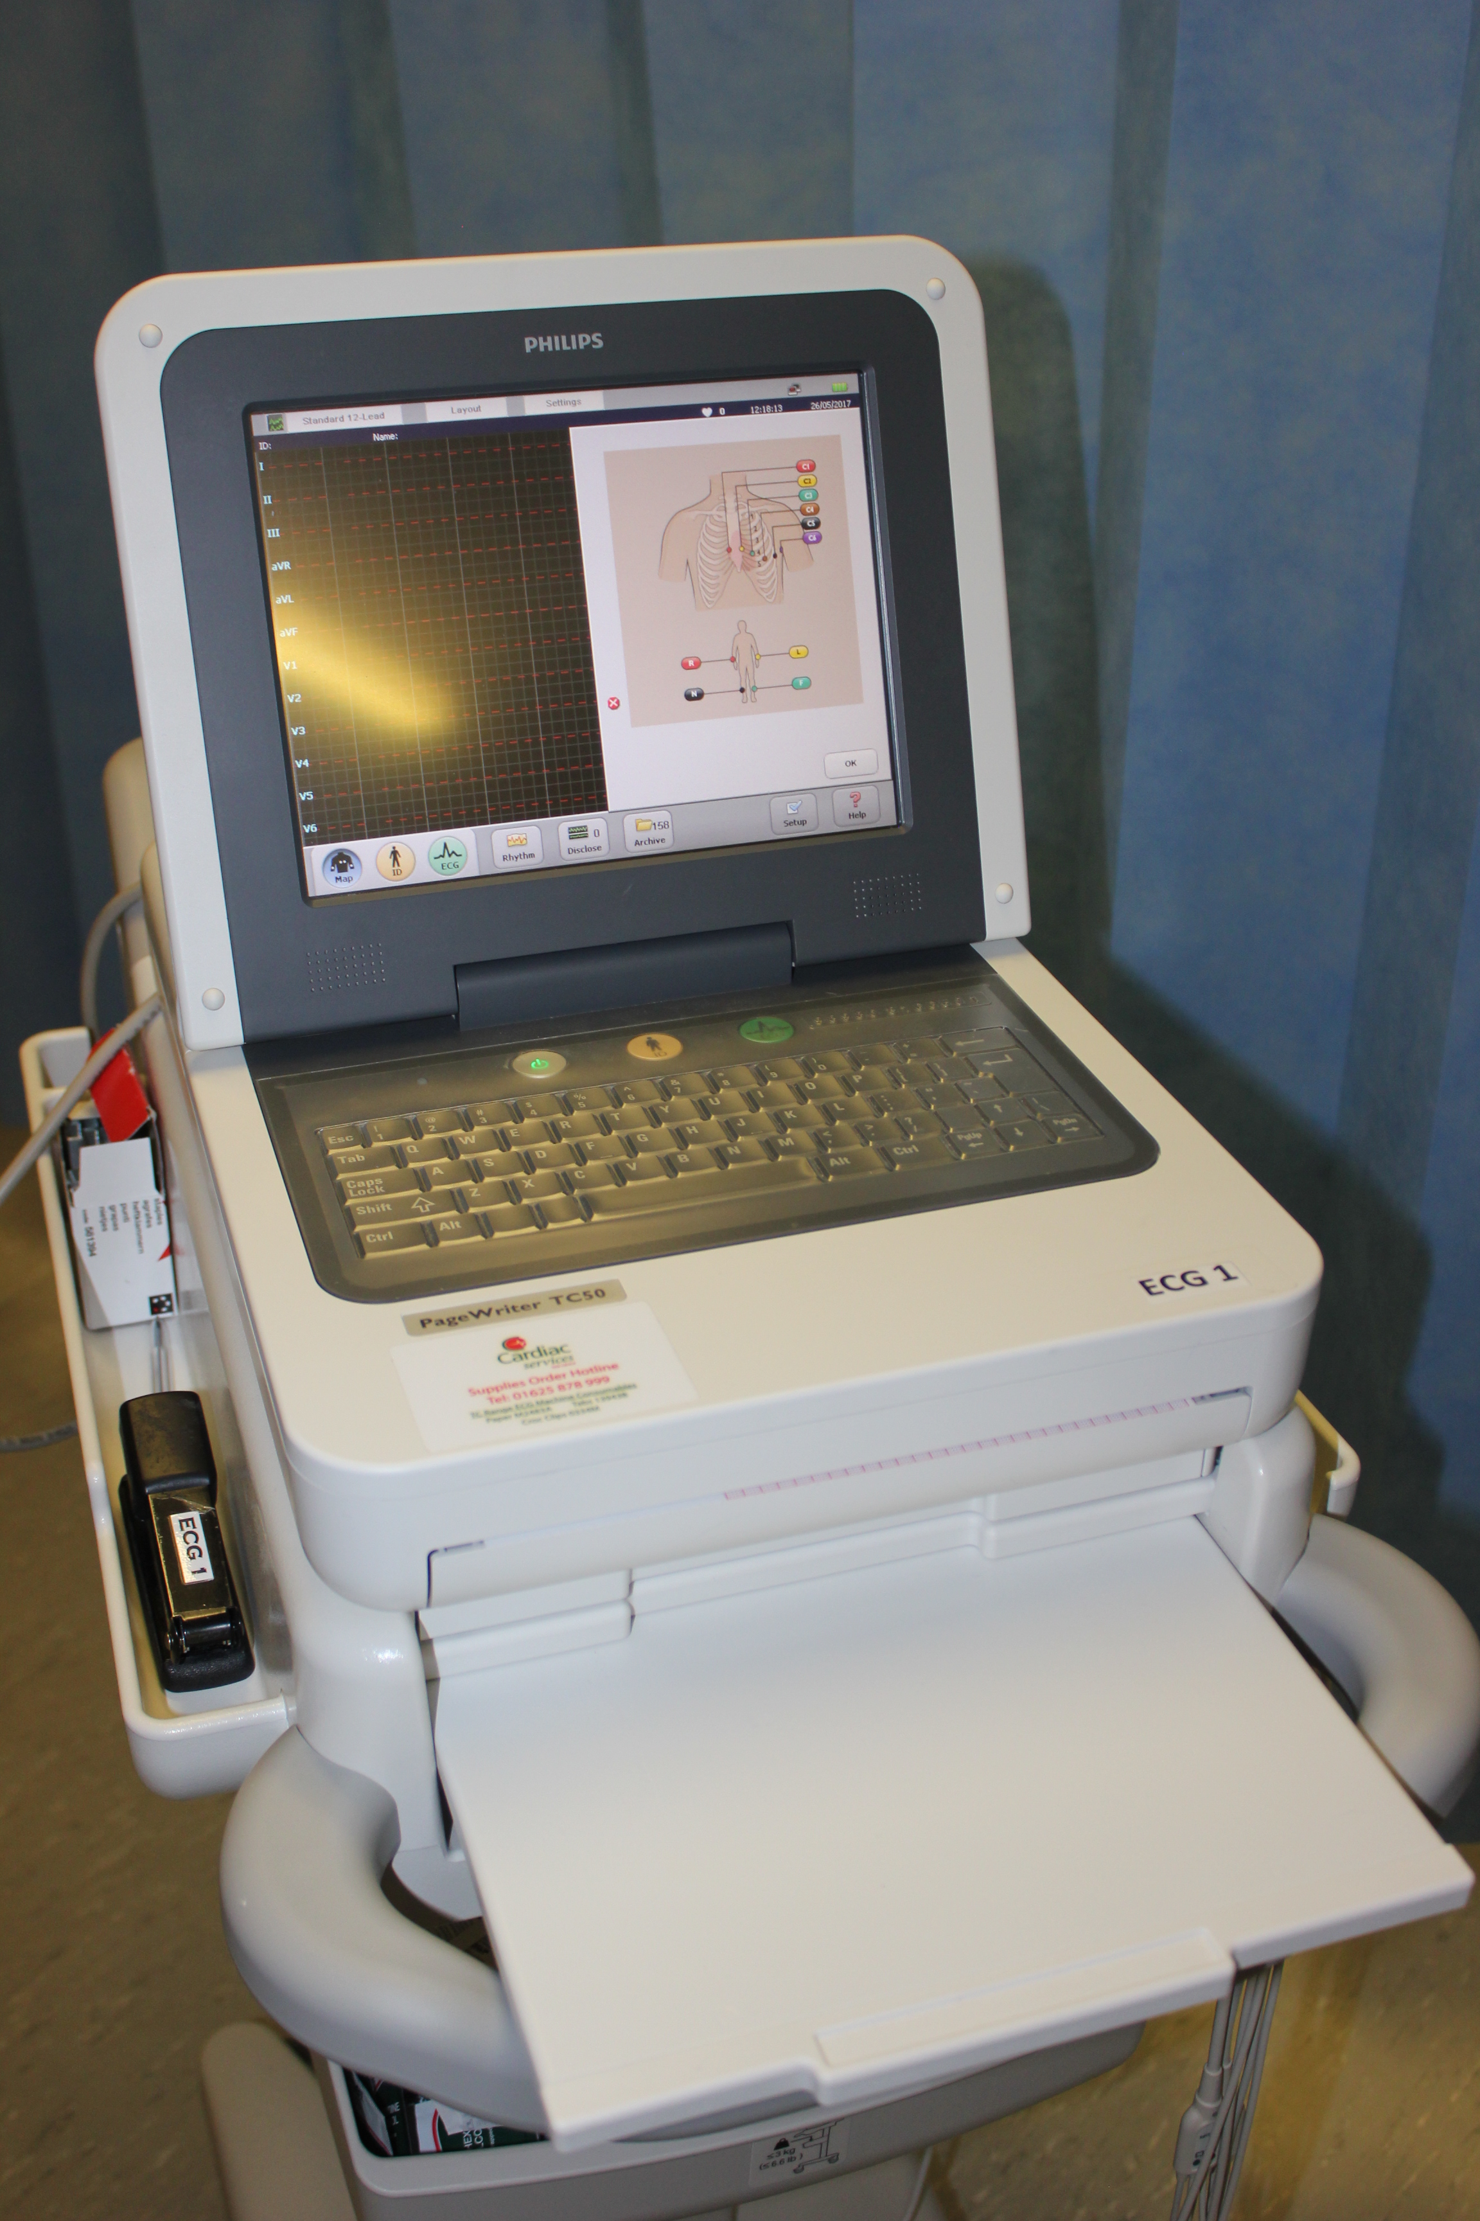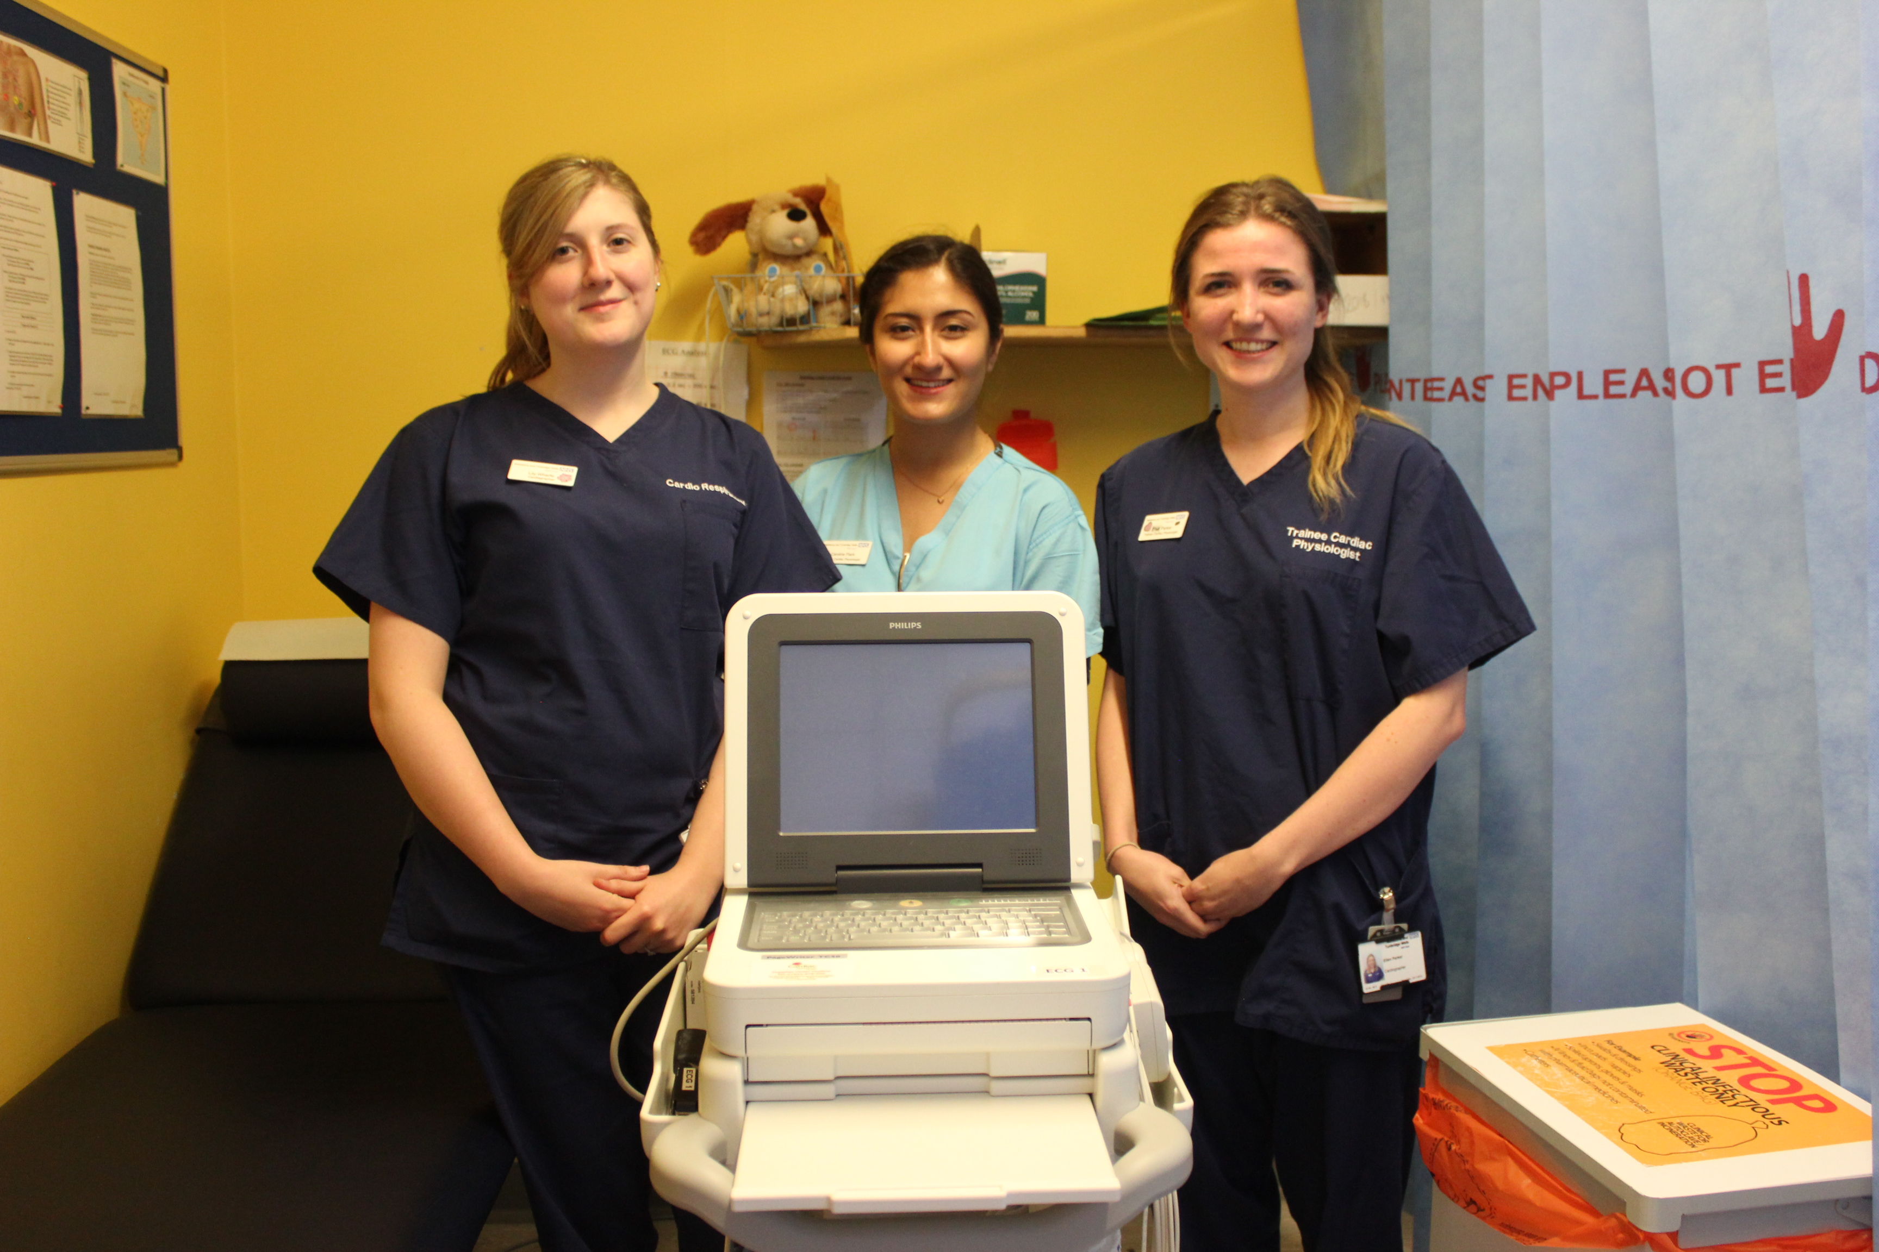

Gynae Treatment Chair for Maidstone Birth Centre  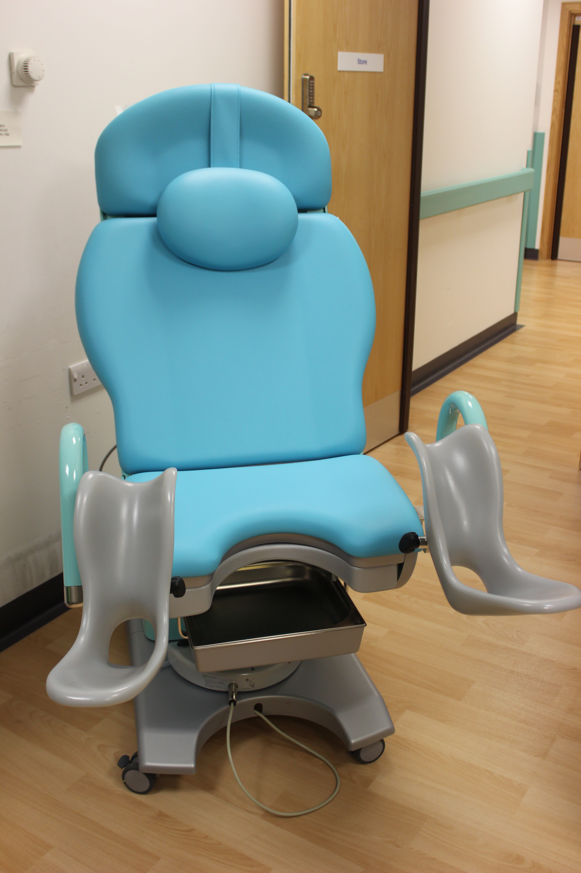 | Automated Dose Dispenser for Nuclear Medicine at Maidstone  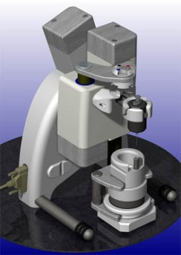

Patient Welfare and amenities – Total spend £14k (2015/16 £58k)

The most significant spends were:

- Complementary therapy (£7k)

Staff Amenities and Welfare – Total spend £65k (2015/16 £35k)

Staff throughout the Trust ‘go the extra mile’ to ensure the best quality of care for patients. The corporate Trustee recognises this commitment and the hard work and care given to patients and to those who visit the Trust.

The majority of the expenditure (86%) is focussed on additional training, allowing staff to develop within their roles and allowing them to enhance patient care and experience.

Other Direct Contributions to the NHS – Total spend £163k (2015/16 £40k)

84% of expenditure in this category has supported the purchase of fixtures and fittings. The most significant purchases were:

- 12 Volker Beds (£30k)
- 2 Gynae Couches (£16k)
- Upgrade to patient area in Oncology (£15k)

Income

The graph below shows an analysis of income sources for the current and two previous financial years:

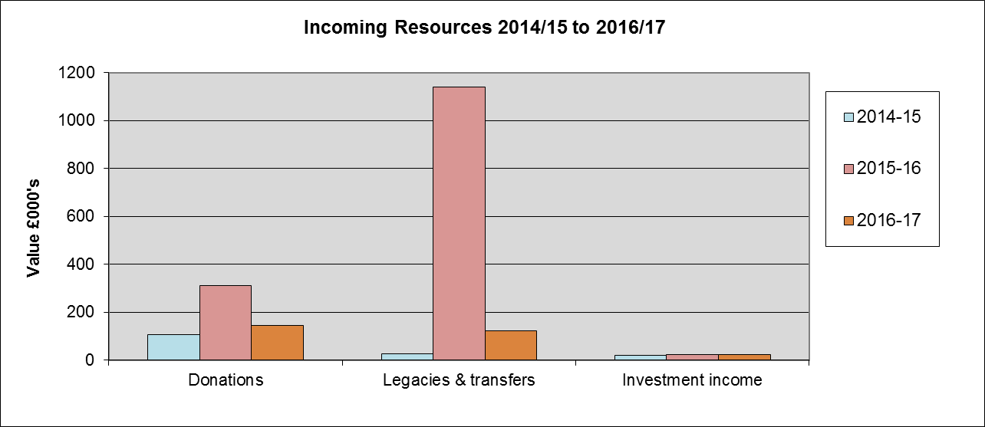

The majority of income received by the Charity is from grateful patients and relatives who wish to support the Trust in appreciation of the work and care provided by the Trust staff.

A total of £145k was received from donations (£312k 2015/16) and £125k from legacies (£1,139k 2015/16). We have immense appreciation of the generosity of all donors and their families. Significant donations and legacies over £10k are highlighted below.

The Trust received the following significant donations (over £10k) during the year:

 | £000’s
Prostate Cancer Support | 49
TWADRA to purchase the Libre System for Type 1 Diabetic Patients | 10

Legacies

Legacies were received from the estates of the following:

 | £000’s
Mollie Hayling Legacy (Final disbursement) | 116
Walter Ashlee Legacy | 9
Total legacy funding received | 125

The Trust holds no material assets bequeathed to the charity but subject to a life tenancy interest held by a third party.

The Corporate Trustee is most appreciative of every gift and sends thanks to all who have supported the Trust in this way.

Fundraising

The Trust has an active ‘just giving’ page that received donations of £17k this year compared to £10k last year. The Trust did not undertake any other fundraising activity during 2016/17.

Gift Aid is being encouraged and staff are reminded to ask donors to use the donation and gift aid forms to increase their donation.

The Trust is exploring options around enhancing our fund raising activities.

Intangible Income

The Statement of Financial Activity does not include any estimation of intangible income in respect of volunteers’ services or the free use of Trust premises.

Looking Forward - our plans for the future

The Trustee is dedicated to strengthening the long term viability of the Charity, working in partnership with the Trust to achieve their aim to deliver a first class healthcare service for our patients.

The Trust is a member of the Association of NHS Charities and continues to work with colleague organisations to ensure best practice in the Charity’s activities.

The charity received good levels of voluntary income in 2016/17, thanks to the generosity of various donors, some of which are highlighted above. The Trust reviewed its investment income strategy in 2016/17, which was presented to the Charitable Funds Committee on the 28th May 2016.

Making donations

There are several ways that the generosity of those wishing to donate to our funds can be enhanced through tax saving schemes such as Gift Aid and through the internet on www.justgiving.com/mtwnhscharitablefund

We hope that you will continue to support the Trust as it seeks to enhance patient care and support staff in delivering a first class service to patients, relatives and visitors.

If you would like to find out more about the work of the Charity, make a donation, or raise funds, please contact the Trust at the principal office (details on page 4), via our website at www.mtw.nhs.uk or complete the attached form at the end of the report and send it to us.

Statement of Trustee responsibilities in respect of the Trustee annual report and the financial statements

Under charity law, the Corporate Trustee is responsible for preparing the Annual Report and the financial statements for each financial year which show a true and fair view of the state of affairs of the Charity and of the financial position at the end of the year.

In preparing these financial statements, the trustees are required to:

- select suitable accounting policies and then apply them consistently;
- observe the methods and principles in the Charities SORP
- make judgements and estimates that are reasonable and prudent;
- state whether applicable UK accounting standards have been followed, subject to any
material departures disclosed and explained in the financial statements;
- prepare the financial statements on the going concern basis unless it is inappropriate to presume that the charity will continue its activities.

The trustee is required to act in accordance with the trust deed of the charity, within the framework of trust law. They are responsible for keeping proper accounting records that disclose with reasonable accuracy at any time the financial position of the charity and to enable them to ensure that the financial statements comply with the Companies Act 2006. They are also responsible for safeguarding the assets of the charity and the group and hence taking reasonable steps for the prevention and detection of fraud and other irregularities. They have general responsibility for taking such steps as are reasonably open to them to safeguard the assets of the charity and to prevent and detect fraud and other irregularities.
The trustees are responsible for the maintenance and integrity of the corporate and financial information included on the charitable company’s website. Legislation in the United Kingdom governing the preparation and dissemination of financial statements may differ from legislation in other jurisdictions.

Statement as to disclosure to our auditors

In so far as the trustees are aware at the time of approving our trustees’ annual report:
- there is no relevant information, being information needed by the auditor in connection with preparing their report, of which the group’s auditor is unaware, and
- the trustees, having made enquiries of fellow directors and the group’s auditor that they ought to have individually taken, have each taken all steps that he/she is obliged to take as a director in order to make themselves aware of any relevant audit information and to establish that the auditor is aware of that information.

By Order of the Trustee

Signed:

David Highton,
Chair of Trust Board
Maidstone and Tunbridge Wells NHS Trust

Date: …………………….

Independent examiner's report to the trustees of Maidstone and Tunbridge Wells NHS Trust Charitable Fund
I report on the accounts of Maidstone and Tunbridge Wells NHS Trust Charitable Fund for the year ended 31 March 2017, which are set out on pages 19 to 32.
Your attention is drawn to the fact that the charity's trustees have prepared the charity's accounts in accordance with the Statement of Recommended Practice 'Accounting and Reporting by Charities preparing their accounts in accordance with the Financial Reporting Standard applicable in the UK and Republic of Ireland (FRS 102) issued in May 2014 in preference to the Statement of Recommended Practice 'Accounting and Reporting by Charities: Statement of Recommended Practice (revised 2005)' issued in April 2005 which is referred to in the Charities (Accounts and Reports) Regulations 2008 but has been withdrawn. I understand that the charity's trustees have done this in order for the charity's accounts to give a true and fair view in accordance with United Kingdom Generally Accepted Accounting Practice effective for reporting periods beginning on or after 1 January 2015.
This report is made solely to the charity's trustees, as a body, in accordance with the regulations made under section 154 of the Charities Act 2011. My work has been undertaken so that I might state to the charity's trustees those matters I am required to state to them in an independent examiner's report and for no other purpose. To the fullest extent permitted by law, I do not accept or assume responsibility to anyone other than the charity and the charity's trustees as a body, for my work, for this report, or for the opinions I have formed.

Respective responsibilities of trustees and examiner
The charity's trustees are responsible for the preparation of the accounts. The charity's trustees consider that an audit is not required for this year under section 144(2) of the Charities Act 2011 and that an independent examination is needed. The charity’s gross income exceeded £250,000 and I am qualified to undertake the examination by being a qualified member of CIPFA.
It is my responsibility to:
- examine the accounts under section 145 of the Charities Act 2011;
- to follow the procedures laid down in the general Directions given by the Charity Commission under section 145(5)(b) of the Charities Act 2011; and
- to state whether particular matters have come to my attention.

Basis of independent examiner's report
My examination was carried out in accordance with the general Directions given by the Charity Commission. An examination includes a comparison of the accounts with the accounting records kept by the charity. It also includes consideration of any unusual items or disclosures in the accounts, and seeking explanations from you as trustees concerning any such matters. The procedures undertaken do not provide all the evidence that would be required in an audit and consequently no opinion is given as to whether the accounts present a 'true and fair' view and the report is limited to those matters set out in the statement below.

Independent examiner's statement
In connection with my examination, no other matter has come to my attention:
- which gives me reasonable cause to believe that in any material respect the requirements:
- to keep accounting records in accordance with section 130 of the Charities Act 2011; and
- to prepare accounts which accord with the accounting records and comply with the accounting requirements of the Charities Act 2011;
have not been met; or
- to which, in my opinion, attention should be drawn in order to enable a proper understanding of the accounts to be reached.

Darren Wells CPFA
Grant Thornton UK LLP
Chartered Accountants
2nd Floor
St John’s House
Haslett Avenue West
Crawley
RH10 1HS
xx June 2017

Statement of Financial Activities for the year ended 31 March 2017

 |  |  |  |  | 2016/17 | 2015/16
 | Note | Unrestricted Funds | Restricted Funds | Endowment Funds | Total Funds | Total Funds
 |  | £000 | £000 | £000 | £000 | £000
Income | 2
Donations |  | 84 | 61 | 0 | 145 | 312
Legacies |  | 9 | 116 | 0 | 125 | 1,139
Total Donations and Legacies |  | 93 | 177 | 0 | 270 | 1,451
Investment income |  | 6 | 15 | 0 | 21 | 23
Total income |  | 99 | 192 | 0 | 291 | 1,474
Expenditure | 3
Costs of generating funds | 3.1 | (1) | (1) | 0 | (2) | (2)
Charitable Activities
Activities in furtherance of Charity’s objectives | 3.2 | (306) | (558) | 0 | (864) | (793)
Total expenditure |  | (307) | (559) | 0 | (866) | (795)
Gains / (losses) on investments | 4 | 12 | 38 | 0 | 50 | (21)
Net income/expenditure |  | (197) | (329) | 0 | (526) | 658
Fund transfer | 4 | 0 | 0 | 0 | 0 | 0
Net movement in funds | 4 | (197) | (329) | - | (526) | 658
Fund balances brought forward at 31 March 2016 |  | 410 | 1,307 | 9 | 1,726 | 1,068
Fund balances carried forward at 31st March 2017 |  | 213 | 978 | 9 | 1,200 | 1,726

The notes at pages 22 to 34 form part of these financial statements

Balance Sheet as at 31 March 2017
 |  |  |  |  | 2016/17 | 2015/16
 | Note | Unrestricted Funds £000’s | Restricted Funds £000’s | Endowment Funds £000’s | Total Funds £000’s | Total Funds £000’s
Fixed Assets | 5
Investments | 5.1 | 112 | 515 | 0 | 627 | 577
Total Fixed Assets |  | 112 | 515 | 0 | 627 | 577
Current Assets | 6
Cash at bank and in hand | 6.1 | 191 | 881 | 9 | 1,081 | 1,514
Debtors due within one year | 6.2 | 0 | 0 | 0 | 0 | 0
Total current Assets |  | 191 | 881 | 9 | 1,081 | 1,514
Liabilities
Creditors due within one year | 7.1 | (90) | (418) | 0 | (508) | (365)
Net Current Assets / (Liabilities) |  | 101 | 463 | 9 | 573 | 1,149
Total Net Assets |  | 213 | 978 | 9 | 1,200 | 1,726
Funds of the Charity | 8
Endowment Funds |  | 0 | 0 | 9 | 9 | 9
Restricted Funds |  | 0 | 978 | 0 | 978 | 1,307
Unrestricted Funds |  | 213 | 0 | 0 | 213 | 410
Total Funds |  | 213 | 978 | 9 | 1,200 | 1,726

For purposes of splitting assets / liabilities by category, restricted and unrestricted funds are categorised by transactions, whilst endowment funds are categorised only as cash.

The charitable funds financial statements were approved by the Trust Board on the 19 July 2017 and signed on its behalf as Trustee by:

_______________________________ ___________________
David Highton, Date
Chair of Trust Board, Maidstone and Tunbridge Wells NHS Trust

Statement of cash flows

Cash flow as at 31 March 2017
Cash flows from operating activities: | 2016/17 | 2015/16
 | £000 | £000
Net cash provided by (used in) operating activities | (455) | 949
Cash flows from investing activities:
Dividends, interest and rents from investments | 22 | 23
Proceeds from the sale of property, plant and equipment | 0 | 0
Purchase of property, plant and equipment | 0 | 0
Proceeds from sale of investments | 0 | 0
Purchase of investments | 0 | 0
Net cash provided by (used in) investing activities | 22 | 23
Cash flows from financing activities:
Repayments of borrowing | 0 | 0
Cash flows from new borrowing | 0 | 0
Receipt of endowment | 0 | 0
Net cash provided by (used in) financing activities | 0 | 0
Change in cash and cash equivalents in the reporting period | (433) | 972
Cash and cash equivalents at the beginning of the reporting period | 1,514 | 542
Cash and cash equivalents at the end of the reporting period | 1,081 | 1,514
Net income / (expenditure) for the reporting period (as per the statement of financial activities) | (525) | 658
Adjustments for:
(Gains) / losses on investments | (50) | 21
Dividends, interest and rents from investments | (22) | (23)
Loss / (profit) on the sale of fixed assets | 0 | 0
(Increase ) / decrease in debtors | 0 | 0
(Increase ) / decrease in creditors | 142 | 293
Net cash provided by (used in) operating activities | (455) | 949
Analysis of cash and cash equivalents
Cash in hand | 1,081 | 1,514

Notes to the financial statements for the year ended 31 March 2017

- Principal accounting policies

  - Basis of preparation
The financial statements have been prepared in accordance with applicable Accounting and Reporting by Charities: Statement of Recommended Practice (SORP) applicable to charities preparing their accounts in accordance with the Financial Reporting Standard applicable in the UK and Republic of Ireland (FRS 102) effective 1 January 2015 and the Charities Act 2011. A summary of the principal accounting policies, which have been applied consistently, are set out below.

The financial statements are prepared in accordance with the historical cost convention, except for Investments, which are included at market value. During the year, the Charity reviewed its accounting policies and made no changes.

The Trustees consider that there are no material uncertainties about the Charity’s ability to continue as a going concern and uncertainties affecting the current year’s accounts. The charity ended the year with £1.2m in available funds which the trustees consider to be sufficient to ensure that the charity is able to meet its existing plans and obligations. The charity receives donations and legacies at differing levels from year to year but the underlying healthcare activities are continuing which supports a reasonable assumption of future donations. The Trustees are considering a range of proposals to enhance the visibility of the charity and to increase its fundraising effectiveness.
  - Reconciliation with previous generally accepted accounting practices
These accounts are continued to be prepared in accordance with FRS 102 and the charities SORP FRS 102.

Governance and administration costs are classified as a support cost and have therefore been apportioned between fundraising activities and charitable activities on a cost basis (see note 3). The Trustees consider this is an equitable treatment to avoid disadvantaging funds with high volume low value transactions. All funds attract administrative costs even without any expenditure as these have to be monitored, fund managers approached for future plans, investment transactions and overhead charges. The cost of the transaction does not necessarily reflect on the work involved to achieve that expenditure and therefore consistency is maintained by working with an activity cost based apportionment.

  - Income
Donations, grants, legacies and gifts in kind (voluntary Income)
All incoming resources are recognised once the charity has evidence of entitlement and it is probable (more likely than not) that the resources will be received and the monetary value can be measured with sufficient reliability. It is not the charity’s policy to defer income.

Where there are terms or conditions attached to the incoming resource (particularly grants) then these must be met before the income is recognised as the entitlement will not be evidenced, or where there is uncertainty that the conditions can be met, and then the income is not recognised in the year. It is not the Charity’s policy to defer income even where a pre-condition for use is imposed.

Legacies are accounted for as incoming resource either on receipt or where the receipt of the legacy is probable. Receipt is provable when:

- Confirmation has been received from the representatives of the estate(s) that probate has been granted
- The executors have established that there are sufficient assets in the estate to pay the legacy and
- All conditions attached to the legacy have been fulfilled or are within the charity’s control
- Where the amount of the legacy can be reliably estimated.
- Legacies which are subject to a life interest party are not recognised.

Where a reliable estimate cannot be identified, then the legacy is disclosed as a contingent asset.

Income resources from Capital Endowments are placed into an income fund when received. Income will be placed into funds in accordance with donors’ wishes, but without forming a binding trust, unless a signed document is received and approved by Trustees.

Gifts in kind are valued at a reasonable estimate of their value to the Charity. Gifts donated for resale are included as income either when they are sold or at the estimated resale value after deduction of the cost to sell the goods.

Intangible Income
Intangible income, which comprises donated services or use of Trust property, is included in income at a valuation which is an estimate of the financial cost borne by the donor where such a cost is material, quantifiable and measurable. No income is recognised when there is no financial cost borne by a third party.

Investment Income
Investment Income and gains and losses on investments are credited / charged to the funds quarterly using the average fund balance to apportion the gain / loss.

  - Expenditure
All expenditure is accounted for on an accruals basis and has been classified under headings that aggregate all costs related to the category of expense shown in the Statement of Financial Activities. All expenditure is recognised when the following criteria are met:

- There is a present legal of constructive obligation to make a payment to a third party – primarily to the Trust in furtherance of the charitable objectives.
- It is more likely than not that a transfer of benefits (usually a cash payment) will be required in settlement
- The amount of the obligation can be measured or estimated reliably.

The Trustees have control over the amount and timing of grant payments and are usually given with the condition that an item or service has been purchased. Conditions have to be met before the liability is recognised.

Irrecoverable VAT
Irrecoverable VAT is charged against the category of resources expended for which it was incurred.

Allocation of support costs
Support costs are those costs which do not relate directly to a single activity. These include some staff costs, costs of administration, internal and external audit costs and IT support. These costs include recharges of appropriate proportions of the staff costs and overheads from Maidstone and Tunbridge Wells NHS Trust and are apportioned on an average fund balance monthly across all funds.

Charitable activities
Expenditures are given as grants made to third parties (including NHS bodies) in furtherance of the charitable objectives of the funds. They are accounted for on an accruals basis, in full, as liabilities of the Charity when approved by the trustees and accepted by the beneficiaries.

Exceptional Items
Exceptional Items are shown on the face of the Sofa under the category to which they relate with further detail, where appropriate, provided in the notes.

Costs of generating funds
The costs of generating funds are the costs associated with generating income for the funds held on trust. This will include the costs associated with Investment Managers and other promotional and fundraising events including any trading activities.

Recognition of liabilities
Liabilities are recognised as and when an obligation arises to transfer economic benefits as a result of past transactions or events.

Analysis of grants
The Charity does not make grants to individuals. All grants are made to the Trust to provide for the care of NHS patients in furtherance of it charitable aims. The total cost of making grants, including support costs, is disclosed on the face of the Statement of Financial Activities and further analysis in relation to activity is provided in note 3.

  - Structure of funds
Unrestricted funds are general funds, which are available for use at the discretion of the Trustee in furtherance of the objectives of the Charity. Funds which are not legally restricted but which the Trustee has chosen to earmark for set purposes are designated funds.

Where there is a legal restriction or a binding agreement with a donor, on the purpose for which a donation may be use, the fund is classified in the accounts as a restricted fund.

Endowment Funds are funds that hold capital in perpetuity. Investment income resulting from these capital holdings may be utilised in accordance with the donor’s wishes.

Transfers between funds are made at the discretion of the Trustee, taking account of any restrictions imposed by the donor.

The purposes of each fund with a balance in excess of £10,000 at the year-end are set out in note 8.1 to the financial statements.

  - Finance and Operating Leases
The Charity has no finance or operating leases

  - Fixed Assets
Tangible Fixed Assets
The Charity held no tangible fixed assets during the year.

Investments Fixed Assets
Investments held by the Trustee’s investment advisers are included at closing market value at the balance sheet date. Any realised and unrealised gains and losses on revaluation or disposal are combined in the Statement of Financial Activities. All investments held are pooled across all of the funds. Please see investment strategy on page 7 for further information.

Investment properties
The Charity held no investment properties during the year

  - Stocks
The Charity held no stocks during the year

  - Gains and losses
Realised gains and losses on investments are calculated as the difference between sales proceeds and opening market value (or date of purchase if later).

Unrealised gains and losses are calculated as the difference between market value at the year end and opening market value (or date of purchase if later). Investment income and gains/losses are allocated quarterly according to the average fund balance, to the appropriate fund and included within the Statement of Financial Activities.

  - Cash and Cash equivalents
Cash is represented by the balance maintained in the charity bank accounts and is used to meet the operational costs of the charity as they fall due.

Cash equivalents are short term liquid investments held for a period of 3 months or less in interest bearing accounts that are readily convertible to cash with no risk of change in value.

As a requirement of FRS 102, a statement of cash flows has been included in the accounts to provide information about the ways in which the charity uses the cash generated by its activities and about changes in cash and cash equivalents held by the charity.

  - Financial Instruments
The Charity only has financial assets and financial liabilities that qualify as basic financial instruments. Basic financial instruments are initially recognised at transaction value and subsequently measured at their settlement value with the exception of investments which are subsequently measured at fair value.

  - Pensions
The Charity has no employees.

  - Prior Year Adjustments
There has been no change to the accounts of the prior years.

- Income

 |  |  |  | 2016/17 | 2015/16
Voluntary Income | Unrestricted Funds | Restricted Funds | Endowment Funds | Total Funds | Total Funds
 | £000 | £000 | £000 | £000 | £000
Donations | 67 | 61 | 0 | 128 | 302
Donations – website | 17 | 0 | 0 | 17 | 10
Legacies | 9 | 116 | 0 | 125 | 1,139
Total Donations and Legacies | 93 | 177 | 0 | 270 | 1,451
Investment income
Dividends from investment portfolio | 5 | 13 | 0 | 18 | 18
Interest from investment portfolio | 0 | 0 | 0 | 0 | 3
Bank Interest | 1 | 2 | 0 | 3 | 2
Total Investment income | 6 | 15 | 0 | 21 | 23
Total incoming resources | 99 | 192 | 0 | 291 | 1,474

- Expenditure

3.1. Cost of generating funds |  |  |  | 2016/17 | 2015/16
 | Unrestricted Funds | Restricted Funds | Endowment Funds | Total Funds | Total Funds
 | £000 | £000 | £000 | £000 | £000
Investment managers fees | (1) | (1) | 0 | (2) | (2)

 |  |  |  |  |  |  | 2016/17 | 2015/16
3.2. Charitable Activities | Unrestricted Funds |  |  | Restricted Funds | Endowment Funds |  | Total Funds | Total Funds
 | £000 |  |  | £000 | £000 |  | £000 | £000
Patients welfare and amenities
Hospitality | 0 |  |  | 0 | 0 |  | 0 | 0
Other | (8) |  |  | 0 | 0 |  | (8) | (46)
Complimentary Therapies | 0 |  |  | (6) | 0 |  | (6) | (12)
Total patients welfare and amenities | (8) |  |  | (6) | 0 |  | (14) | (58)
Staff welfare and amenities
Training | (51) |  |  | (5) | 0 |  | (56) | (19)
Hospitality | 0 |  |  | 0 | 0 |  | 0 | 0
Christmas Events | (7) |  |  | 0 | 0 |  | (7) | (6)
Other | (2) |  |  | (0) | 0 |  | (2) | (10)
Total staff welfare and amenities | (60) |  |  | (5) | 0 |  | (65) | (35)
Medical and Rehabilitation Equipment |  | (47) | (450) |  | 0 | (497) |  |  | (608)
Furniture and Fittings |  | (130) | (7) |  | 0 | (137) |  |  | (20)
Other |  | (28) | 2 |  | 0 | (26) |  |  | (20)
IT |  | (20) | (54) |  | 0 | (73) |  |  | 0
Governance - Salaries & overheads |  | (11) | (36) |  | 0 | (47) |  |  | (49)
Governance - Audit Fees (external) |  | (1) | (3) |  | 0 | (4) |  |  | (3)
Total contribution to Maidstone and Tunbridge Wells NHS Trust |  | (237) | (548) |  | 0 | (785) |  |  | (700)
Total cost of charitable activities |  | (306) | (558) |  | 0 | (864) |  |  | (793)
Total resources expended |  | (307) | (559) |  | 0 | (866) |  |  | (795)

Employee Information

The Charity does not employ any staff directly, although members of the finance team support the governance and administration function of the Charity. Their costs have been included in the table above.

During the year none of the members of the NHS Trust Board or senior NHS staff or parties related to them were beneficiaries of the Charity. Neither the Corporate Trustee nor any member of the NHS Trust Board has received honoraria, emoluments, or expenses in the year and the Corporate Trustee has not purchased trustee indemnity insurance.

- Net Movements in Funds

 |  |  |  | 2016/17 | 2015/16
 | Unrestricted Funds | Restricted Funds | Endowment Funds | Total Funds | Total Funds
 | £000 | £000 | £000 | £000 | £000
Net Incoming/(outgoing) resources before other recognised gains and losses | (209) | (366) | 0 | (575) | 679
Gains/Losses on Investments | 12 | 38 | 0 | 50 | (21)
Total net movement in funds | (197) | (329) | 0 | (526) | 658
Funds transfers | 0 | 0 | 0 | 0 | 0
Total net movement in funds after transfers | (197) | (329) | 0 | (526) | 658
Fund balances at 1 April 2016 | 410 | 1,307 | 9 | 1,726 | 1,068
Fund balances carried forward at 31 March 2017 | 213 | 978 | 9 | 1,200 | 1,726

- Analysis of Movement of Fixed Asset Investments

5.1. Investments | Carrying value at 01/04/16 | Additions to investment at cost | Disposals at carrying value | Net gain / (loss) on revaluation | Carrying value at 31/03/2017
 | £000 | £000 | £000 | £000 | £000
CAF Bond Income Fund (UK) | 245 | 0 | 0 | 3 | 248
CAF Equity Growth Fund (UK) | 332 | 0 | 0 | 47 | 379
Total Fixed Asset Investments | 577 | 0 | 0 | 50 | 627

- Current Assets

6.1. Cash and cash investments | 2016/17 | 2015/16
 | Total Funds | Total Funds
 | £000 | £000
Cash Investments:
Santander | 82 | 82
Clydesdale | 86 | 86
CAF | 80 | 80
Nat West | 0 | 0
Operational Bank Accounts:
GBS bank account | 750 | 1,219
Nat West bank account | 83 | 47
Total Cash and Cash Investments | 1,081 | 1,514

6.2. Debtors | 2016/17 | 2015/16
 | Total Funds | Total Funds
 | £000 | £000
Amounts falling due within one year | 0 | 0
Total Debtors due within one year | 0 | 0

- Current Liabilities

7.1. Creditors | 2016/17 | 2015/16
 | Total Funds | Total Funds
 | £000 | £000
Amounts falling due within one year
Trade Creditors | (157) | (68)
Other Creditors | 0 | 0
Owed to Maidstone and Tunbridge Wells NHS Trust | (342) | (291)
Accruals | (9) | (6)
Total Creditors due within one year | (508) | (365)

- Details of Funds

Description | Fund number | Fund Type | Balance 01-Apr-2016 | Incoming Resources | Resources Expended | Gain & (losses) on  revaluation & disposal of investment assets | Balance 31-Mar-2017
 |  |  | £000 | £000 | £000 | £000 | £000
A.Haines – Cip | 67020 | Endowment | 7 | 0 | 0 | 0 | 7
E.C.Beedle Fund - Cip | 67010 | Endowment | 2 | 0 | 0 | 0 | 2
Total Endowment Funds |  |  | 9 | 0 | 0 | 0 | 9

Description | Fund number | Fund Type | Balance 01-Apr-2016 | Incoming Resources | Resources Expended |  | Gain & (losses) on  revaluation & disposal of investment assets | Balance 31-Mar-2017
 |  |  | £000 | £000 | £000 | £000 |  | £000
Cardiac Equip Fd Ms Crow Legac | 65450 | Restricted | 179 | 2 | (18) | 5 |  | 169
Cardio Equip TW Hayling Legacy | 65460 | Restricted | 682 | 124 | (473) | 20 |  | 353
E&M Dir Diabetes Fund Tw | 65410 | Restricted | 51 | 11 | (2) | 2 |  | 61
Gastrointestinal Fund | 65340 | Restricted | 12 | 0 | (0) | 0 |  | 12
MH Med Equip Fund Restricted | 61040 | Restricted | 34 | 0 | (30) | 1 |  | 6
Neurology Fund | 65990 | Restricted | 17 | 0 | (6) | 0 |  | 12
Oncology Centrifuge Fund | 61490 | Restricted | 24 | 0 | (0) | 0 |  | 25
Oncology Equipment Fund | 67170 | Restricted | 157 | 53 | (59) | 5 |  | 156
Oncology Prostate Equip Fund P Ward Legacy | 61310 | Restricted | 10 | 0 | (0) | 0 |  | 10
Pierre Fabre Grant Fund | 61720 | Restricted | 65 | 1 | (4) | 2 |  | 63
E&M Directorate - Frances Gibson Legacy | 65180 | Restricted | 25 | 0 | (0) | 1 |  | 26
Other Restricted Funds (closing balances <£10,000) |  |  | 50 | 1 | 33 | 1 |  | 85
Total Restricted Funds |  |  | 1,307 | 192 | (559) | 38 |  | 978

Description | Fund number | Fund Type | Balance 01-Apr-2016 | Incoming Resources | Resources Expended | Gain & (losses) on  revaluation & disposal of investment assets | Balance 31-Mar-2017
 |  |  | £000 | £000 | £000 | £000 | £000
Radiology Fund | 61590 | Unrestricted | 71 | 7 | (41) | 2 | 39
Special Care Baby Unit Fund TW | 65660 | Unrestricted | 17 | 16 | (9) | 1 | 25
Surgery Directorate Fund | 61140 | Unrestricted | 63 | 3 | (38) | 2 | 30
Trust Management Dir Fund | 61000 | Unrestricted | 57 | 6 | (38) | 2 | 27
Cardiac Fund | 65400 | Unrestricted | (43) | 0 | 83 | 0 | 40
Haematology Development Fund | 65600 | Unrestricted | 15 | 0 | (1) | 0 | 14
Other Unrestricted Funds (closing balances <£10,000) |  |  | 229 | 66 | (263) | 6 | 38
Total Unrestricted Funds |  |  | 410 | 98 | (307) | 12 | 213

  - Nature and Purpose of Material Funds (Closing balance > £10,000)

Restricted Funds | Nature and purpose of Fund
Medical Equipment Maidstone | Supports Maidstone Hospital
Haematology Fund | Supports the Haematology Department at Maidstone Hospital
Oncology Equipment Fund | Supports the Oncology Centre for the purchase of Equipment.
Pierre Fabre Grant Fund | Supports the Oncology Department at Maidstone Hospital with specialist procedures.
Gastrointestinal Fund | Supports the Gastrointestinal Unit at Maidstone Hospital
Neurology Fund | Supports the Neurology Department at Tunbridge Wells Hospital
Oncology Centrifuge Fund | Supports the purchase of a centrifuge for the Oncology Centre
Oncology Prostate Equip Fund | Supports the purchase of Prostate equipment for the Oncology Centre
E&M Directorate Gibson Legacy Fund | Supports the Emergency & Medical Directorate
Cardio Equip Hayling Legacy Fund | Supports the Cardio Respiratory Unit at the Tunbridge Wells Hospital
Cardiac Equip Crow Legacy Fund | Supports the Cardiac Unit at Maidstone Hospital
E&M Dir Diabetes Fund TW | Supports the Diabetic Unit at Tunbridge Wells Hospital
Unrestricted Funds
Cardio Respiratory Fund | Supports the Cardio Respiratory Unit at the Tunbridge Wells Hospital
Haematology Department Fund | Supports the development of Haematology across all sites of the Trust
Special Care Baby Unit Fund | Supports the Special Care Baby Unit at Tunbridge Wells Hospital
Surgery Directorate Fund | Supports the Surgery Directorate
Trust Management Directorate Fund | Supports Maidstone & Tunbridge Wells NHS Trust
Radiology Fund | Supports the Radiology Department at Maidstone Hospital

- Charity Tax

Maidstone and Tunbridge Wells NHS Trust Charity is considered to pass the tests set out in Paragraph 1 Schedule 6 Finance Act 2010 and therefore it meets the definition of a charitable trust for UK income tax purposes. Accordingly, the charity is potentially exempt from taxation in respect of income or capital gains received within categories covered by Part 10 Income Tax Act 2007 or Section 256 of the Taxation of Chargeable Gains Act 1992, to the extent that such income or gains are applied exclusively to charitable purposes.

- Related Parties

The Charity is established to hold the charitable funds of the Maidstone and Tunbridge Wells NHS Trust.

During the year none of the NHS Trust Board or members of key management staff or parties related to them has undertaken any material transactions with the Maidstone and Tunbridge Wells NHS Trust.

The Charity has made revenue and capital payments, in the form of grants, to the Maidstone and Tunbridge Wells NHS Trust, the Corporate Trustee of the charity. In addition £47k (2015/16 £49k) was payable by the Charity to the Trust in respect of contribution to salaries and overheads to support the administration of the Charity. The amount due at the balance sheet date to Maidstone and Tunbridge Wells NHS Trust was £342k (2015/16 £291k).

11. Events after the reporting year
The Trust has not been advised of any potential significant legacies to be received in 2017/18.

Donation Form
Name: | Registered Charity Number 1055215
Address: |  | Post Code:
Email:

Whilst recognising that this does not form a binding trust I would wish my donation of
£……………………………………….….…………………..to be used for: (please tick one of the following)
Wherever it will be most useful within the whole Trust to benefit patients and staff as determined by the Charity (This will be the default if no additional information is provided)

- The Directorate fund that supports ……………………………………………..…Ward / Department.

Payment Methods
- Cheques made payable to Maidstone and Tunbridge Wells NHS Trust Charitable Fund
- Standing Order - Please call us on 01622 224500 to arrange for documentation to be sent
- Make A Donation By Phone – If you would prefer to make a donation over the phone, please call 01622 224500. If you have an email address, we can send you bank details for electronic payments. We will require a remittance advice to enable us to receipt your donation. We currently accept the following cards: Maestro UK; MasterCard; Visa;
- Visit our ‘just giving’ page www.justgiving.com/mtwnhscharitablefund

Gift Aid
If you are a UK taxpayer the Maidstone and Tunbridge Wells NHS Trust Charity (MTW) can reclaim the tax you have paid on every donation you make. You must have paid sufficient UK income or capital gains tax to cover the claim. For every £1 you give we can claim 25p back from the HM Revenue & Customs at no extra cost to you.

YES, I am a UK taxpayer and would like MTW to reclaim tax on this and any future donations

Date……../………./……… Signature………………………………..……………….……………….

Please tick here if you DO NOT wish the Maidstone and Tunbridge Wells NHS Trust Charity to contact you by phone or post about our work

Please tick here if you DO NOT wish the Maidstone and Tunbridge Wells NHS Trust Charity to contact you by email.

Please return to:
Maidstone and Tunbridge Wells NHS Trust, Financial Services, Maidstone Hospital, Hermitage Lane, Maidstone, Kent ME16 9QQ. Telephone 01622 224500 Website: www.mtw.nhs.uk

THANK YOU FOR YOUR SUPPORT

