**TESTING A PATIENT**

**QUICK REFERENCE GUIDE**

* All operators must be trained and competency assessed to use this piece of POCT equipment.
* It is the operator’s responsibility to ensure they are certified to use this piece of POCT equipment.

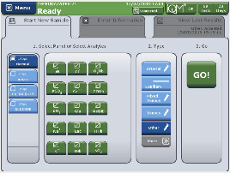

**Step 2**

Select sample type in screen zone 2

**Important** this will print the correct reference ranges

**Step 1**

Select Panel or Analytes

by touch in screen zone 1

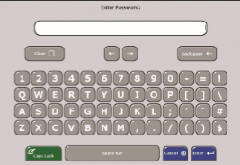

**Step 3**

Press GO!

**Step 4**

Enter your **own ID** code by pin or barcode scan

**Note** Code sharing is against Trust IG and POCT Policies

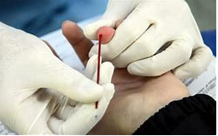

**Step 5 Capillary**

Capillaries should be full without ‘mid-tube’ bubbles Transport sample in a tray

Analyse ASAP

**Step 5 Syringe**

Blood gas syringes ONLY Sample MUST be:

Capped/no bubbles/mixed

Remove filter and expel a few drops of blood

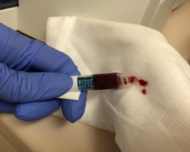

**OR**

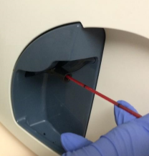

**Step 6 Capillary**

Tilt the capillary until blood is at the leading end and then present to the black rubber luer tip

**Step 6 Syringe**

Place syringe over the end of the sampler. Position it to ensure it is under blood surface but not touching plunger (it blocks suction)

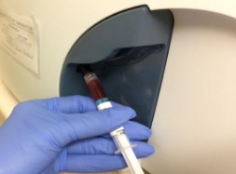

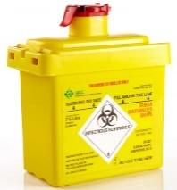

**Step 8**

Remove sample after the ‘beep’ and dispose of into sharps container. If holding sample until result prints exclude bubbles/recap/mix

**Step 7**

Press GO!



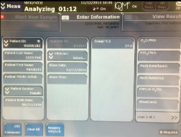

**Step 10**

Analysis will take 3 mins

If you have multiple samples or are queueing for the analyser keep mixing the sample!

**Step 9**

Enter patient details.

Any field marked with * is a mandatory field.

**Note** Trust IG and POCT Policies apply

**Result Quality**

Use heparinised syringes only

Remove bubbles promptly

Mix syringe at bedside & during transit to analyser

Syringes - analyse within 30 mins of venepuncture

Clean up any spilt blood!

**Step 11**

Select the view results tab and then press ‘accept’ to start the result printing

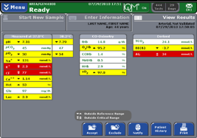



**Remember – always consider the result obtained – does it match the clinical picture?**

**Running CVP**

**QUICK REFERENCE GUIDE**

* All operators must be trained and competency assessed to use this piece of POCT equipment.
* It is the operator’s responsibility to ensure they are certified to use this piece of POCT equipment.



**Information Temperature**

CVP solutions 1,2,3 & 4 MUST be at 22 +/–1°C for 8 hours prior to use.

CVP 5 MUST be used straight from the fridge

**Information Solutions**

New packs must be quality checked before patient use

Dependent upon test menu some or all CVP solutions must be tested

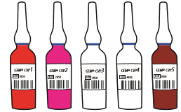

**Step 2**

Just before testing CVP 1,2,3, & 4 should be held above the break line and shaken vigorously for 10sec

CVP 5 should only be finger tapped to mix

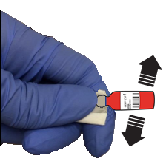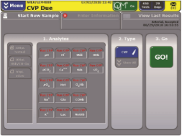

**Step 1**

On the screen select ‘CVP’ from the Type menu

**Step 4**

Select correct CVP Lot tab on screen.

If CVP lot is not in list go to Step 5 otherwise go to 6

**Step 3**

Tap all CVP ampoules (including 5) gently to settle liquid and remove bubbles. Don’t warm the liquid by holding the vial.

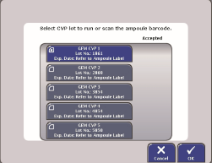



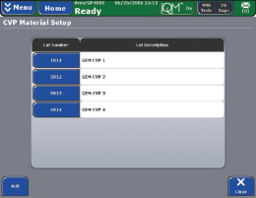

**Step 5 NEW LOT CVP**

Select Menu/GEMWeb Plus

Enter your ID code

Management/Configuration

CVP material set up

Add/Scan barcode/OK

**Step 6**

Press OK to begin testing

**OR**



**Step 8**

Remove ampoule after the beep, & dispose in sharps container – **never re-use**

**Step 7**

Break the ampule and present immediately. (O2/CO2 change rapidly) Ensure the probe does not touch the bottom.

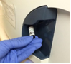

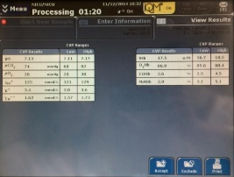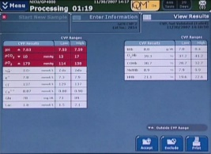

**Step 1**

When results are displayed press accept

Repeat process for each CVP level required

**Step 10**

If the CVP fails run iQM

* Select Menu
* Diagnostics
* Run iQM process
* Run new vial CVP

**Pack Failure**

Test failing CVP are locked

Patient samples can be tested missing failed result

Do NOT run CVP more than 3 times - phone EME

**Electrical Failure**

If power to the analyser is lost the pack will need to be replaced after 20 mins. Multiple short power loss should not cause failure.



**Point of Care Testing (POCT)**[**mtw-tr.POCT@nhs.net**](mailto:mtw-tr.POCT@nhs.net) **Electro-Medical Engineering (EME) 3305**